**BCSE497J - Project-I**

**AI-Driven Diffusion and LoRA Models for customizable 3D Room Visualization and Design Enhancement**

*Submitted in partial fulfillment of the requirements for the degree of*

**Bachelor of Technology**

*in*

**Computer Science Engineering**

*by*

|  |  |
| --- | --- |
| **21BCB0161** | **SARVESHWARARAM M** |
| **21BCE3645** | **NEHAL MENON** |
| **21BDS0001** | **MUKUND NIRANJAN S** |

Under the Supervision of

|  |
| --- |
| **Dr. ANAND PRABU A** |
| Professor Higher Academic Grade |
| School of Advanced Sciences (SAS) |



April 2025

**DECLARATION**

I hereby declare that the project entitled << Project Title >> submitted by me, for the award of the degree of *Bachelor of Technology in Computer Science and Engineering* to VIT is a record of bonafide work carried out by me under the supervision of Prof. / Dr. << Guide Name >>

I further declare that the work reported in this project has not been submitted and will not be submitted, either in part or in full, for the award of any other degree or diploma in this institute or any other institute or university.

Place : Vellore Date :

**Signature of the Candidate**

Note: Include your project title and guide name in highlighted part

**CERTIFICATE**

This is to certify that the project entitled **<< Project Title >>** submitted by << **Student Name (Reg. No) >>**, **School of Computer Science and Engineering**, VIT, for the award of the degree of *Bachelor of Technology in Computer Science and Engineering*, is a record of bonafide work carried out by him / her under my supervision during Winter Semester 2024-2025, as per the VIT code of academic and research ethics.

The contents of this report have not been submitted and will not be submitted either in part or in full, for the award of any other degree or diploma in this institute or any other institute or university. The project fulfills the requirements and regulations of the University and in my opinion meets the necessary standards for submission.

Place : Vellore

Date :

**Signature of the Guide**

**Internal Examiner External Examiner**

Note: Include your project title and student names in highlighted part.

**<< Head of the Department >>**

**<< Programme >>**

**EXECUTIVE SUMMARY**

Traditional 3D modeling tools require significant manual effort and technical expertise, limiting their accessibility for non-professional users. These tools often lack flexibility and intuitive interfaces, making the design process cumbersome and time-consuming. AI advancements, particularly diffusion models and LoRA (Low-Rank Adaptation) models, provide a promising solution to this challenge. Diffusion models are capable of generating complex and realistic 3D structures, while LoRA models allow for efficient, fine-grained customization without requiring extensive computational resources.

The proposed system leverages these AI models to create a user-friendly 3D room visualization tool that accepts multimodal inputs, including text descriptions, sketches, and mood boards. The diffusion model generates an initial room layout, capturing basic elements such as walls, furniture, and textures. The LoRA model enhances this foundation by enabling users to modify details based on iterative feedback, such as changing room colors, rearranging furniture, and applying new textures. This iterative customization process enhances creativity, speeds up design iteration cycles, and enables users to achieve personalized design outcomes efficiently.

By integrating advanced AI models, the system offers real-time, photorealistic outputs that significantly reduce design complexity and effort. The research contributes to the fields of architecture and interior design by democratizing access to high-quality 3D modeling. Applications of the tool include real estate visualization, interior design projects, and virtual reality environment creation. User studies will assess the system's usability, design quality, and performance compared to existing solutions, highlighting its potential to streamline the design process and enhance creative exploration.

*Keywords - 3D modeling, diffusion models, LoRA models, customization, multimodal input, AI-powered design, photorealistic visualization, architectural design, iterative refinement, real-time rendering.*

**ACKNOWLEDGEMENTS**

I am deeply grateful to the management of Vellore Institute of Technology (VIT) for providing me with the opportunity and resources to undertake this project. Their commitment to fostering a conducive learning environment has been instrumental in my academic journey. The support and infrastructure provided by VIT have enabled me to explore and develop my ideas to their fullest potential.

My sincere thanks to Dr. Jaisankar N, Dean - School of Computer Science and Engineering (SCOPE), for his unwavering support and encouragement. His leadership and vision have greatly inspired me to strive for excellence.

I express my profound appreciation to [Head of Department’s Name], the Head of the [Department Name], for his/her insightful guidance and continuous support. His/her expertise and advice have been crucial in shaping throughout the course. His/her constructive feedback and encouragement have been invaluable in overcoming challenges and achieving goals.

I am immensely thankful to my project supervisor, [Supervisor’s Name], for his/her dedicated mentorship and invaluable feedback. His/her patience, knowledge, and encouragement have been pivotal in the successful completion of this project. My supervisor’s willingness to share his/her expertise and provide thoughtful guidance has been instrumental in refining my ideas and methodologies. His/her support has not only contributed to the success of this project but has also enriched my overall academic experience.

<<Company Guide / mentor acknowledgement>>

Thank you all for your contributions and support.

**Name of the Candidate**

**TABLE OF CONTENTS**

|  |  |  |
| --- | --- | --- |
| **Sl.No** | **Contents** | **Page No.** |
|  | **Acknowledgement** | **iii** |
|  | **Executive Summary** | **iv** |
|  | **List of Figures** |  |
|  | **List of Tables** |  |
|  | **Abbreviations** |  |
|  | **Symbols and Notations** |  |
| **1.** | **INTRODUCTION** | **1** |
|  | 1.1 BACKGROUND | **1** |
|  | 1.2 MOTIVATIONS | **1** |
|  | 1.3 SCOPE OF THE PROJECT | **1** |
| **2.** | **PROJECT DESCRIPTION AND GOALS** |  |
|  | 2.1 LITERATURE REVIEW |  |
|  | 2.2 RESEARCH GAP |  |
|  | 2.3 OBJECTIVES  2.4 PROBLEM STATEMENT |  |
|  | 2.5 PROJECT PLAN |  |
| **3.** | **TECHNICAL SPECIFICATION** |  |
|  | 3.1 REQUIREMENTS |  |
|  | 3.1.1 Functional |  |
|  | 3.1.2 Non-Functional |  |
|  | 3.2 FEASIBILITY STUDY |  |
|  | 3.2.1 Technical Feasibility |  |
|  | 3.2.2 Economic Feasibility |  |
|  | 3.2.2 Social Feasibility |  |
|  | 3.3 SYSTEM SPECIFICATION |  |
|  | 3.3.1 Hardware Specification |  |
|  | 3.3.2 Software Specification |  |
| **4.** | **DESIGN APPROACH AND DETAILS** |  |
|  | 4.1 SYSTEM ARCHITECTURE |  |
|  | 4.2 DESIGN |  |
|  | 4.2.1 Data Flow Diagram |  |
|  | 4.2.2 Use Case Diagram |  |
|  | 4.2.3 Class Diagram |  |
|  | 4.2.4 Sequence Diagram |  |
| **5.** | **METHODOLOGY AND TESTING** |  |
|  | Module Description |  |
|  | Testing |  |
|  | Skills Learnt |  |
| **6.** | **PROJECT DEMONSTRATION** |  |
| **7.** | **RESULT AND DISCUSSION** |  |
| **8.** | **CONCLUSION AND FUTURE ENHANCEMENTS** |  |
| **9.** | **REFERENCES** |  |
|  | **APPENDIX A – SAMPLE CODE**  **APPENDIX B – TANGIBLE OUTCOME - PUBLICATION DETAILS - CONFERENCE / JOURNAL/PATENT/BOOK CHAPTER (Even If Communicated…)** |  |

**Note:**

**\*\* - Applicable for Non- CDC only**

**LIST OF FIGURES**

|  |  |  |
| --- | --- | --- |
| **TITLE** | **FIGURE NO.** | **PAGE NO.** |
| Gantt chart | Figure 1 |  |
| System Architecture | Figure 2 |  |
| Data Flow Diagram | Figure 3 |  |
| Use Case Diagram | Figure 4 |  |
| Class Diagram | Figure 5 |  |
| Sequence Diagram | Figure 6 |  |

**1. INTRODUCTION**

#### 1.1 Background

The fields of architecture and interior design have undergone a profound transformation in recent decades with the integration of digital technologies, particularly in the realm of **3D modeling and spatial visualization**. Traditional design workflows, once dominated by manual sketching, physical models, and 2D drafting, have increasingly been replaced—or at least supplemented—by **Computer-Aided Design (CAD)** and **Building Information Modeling (BIM)** platforms. These tools have enabled more precise, data-driven design processes and have improved the accuracy and coordination of architectural documentation. Nevertheless, while these tools offer considerable power, they are also complex and often come with a steep learning curve, especially for non-professional users. Mastery of CAD software requires not only technical fluency but also an understanding of architectural conventions, spatial reasoning, and geometric constraints.

For many users—homeowners, small business owners, or hobbyists—this **technical barrier** has remained a significant obstacle. The need to acquire software licenses, learn specialized programs, and manually configure layouts or structures often discourages casual or novice users from engaging with 3D design tools in a meaningful way. Even professionals may find that existing tools are labor-intensive and time-consuming, especially when iterative feedback or client collaboration is required. This friction in the design process limits the democratization of spatial design and restricts creative exploration to those with the necessary technical background. Furthermore, current tools often lack intuitiveness and real-time responsiveness, both of which are essential for fostering fluid and interactive design workflows.

Against this backdrop, **artificial intelligence (AI)** has emerged as a powerful force capable of reshaping how 3D modeling and design are approached. The latest generation of **generative AI models**, particularly **diffusion models**, has demonstrated the ability to create highly realistic and aesthetically compelling visual content from minimal input. Diffusion models work through a process of iterative denoising, starting with random noise and gradually refining it into a coherent image that aligns with a guiding input—be it a textual prompt, a rough sketch, or other structured data. These models have revolutionized image synthesis and content generation in fields like digital art, game design, and virtual photography. Their strength lies in their capacity to produce high-quality, stylistically consistent visuals that reflect abstract input descriptions in a nuanced way.

Similarly, **Low-Rank Adaptation (LoRA)** models have gained popularity for their ability to fine-tune large, pre-trained AI systems efficiently. Unlike traditional fine-tuning approaches that require significant computational power and training data, LoRA enables lightweight, modular adaptation of models to new tasks or user-specific preferences. This makes it possible to personalize outputs—such as applying a particular aesthetic style, material palette, or spatial arrangement—without needing to retrain the entire generative model. LoRA has shown promise in natural language processing, personalization systems, and image stylization, offering a scalable pathway toward **user-driven customization** in AI systems.

While the success of these AI models in visual media and language generation has been well documented, their application within **architectural and interior design contexts remains an emerging and underexplored area**. Most current generative design systems focus on producing static 2D imagery or floor plans, with limited capacity for real-time interaction or immersive visualization. Furthermore, few of these systems are designed with end-user customization in mind—especially customization that is intuitive and accessible to those without technical training. This presents a critical gap in the existing digital design landscape: how to enable users—regardless of expertise level—to create, visualize, and refine spatial designs in a fluid and meaningful way using AI.

This research project seeks to address this gap by developing a **next-generation 3D room design and customization platform** that combines the capabilities of **diffusion models for initial scene generation** with the **fine-tuning and personalization potential of LoRA models**. The system will allow users to provide input through multiple modalities, including **natural language descriptions**, **sketches**, and **visual mood boards**, which are then interpreted and processed into a structured format by the platform’s input handling module. From there, the **diffusion model** generates a base 3D room layout, including elements such as walls, flooring, windows, furniture, and décor, informed by the input's semantic and stylistic cues.

Once the initial layout is generated, users can iteratively refine the design through real-time interaction. This is facilitated by the **LoRA Customization Module**, which applies user feedback to selectively modify aspects of the design without altering unrelated elements. For instance, if a user wants to replace a modern sofa with a vintage armchair or change the room’s lighting to a warmer tone, the LoRA model interprets these changes and updates the scene accordingly. This two-stage architecture—generation followed by refinement—mirrors how designers work in real life: moving from conceptualization to detailed adjustment based on ongoing feedback and evolving vision.

The use of **multimodal input** is another core innovation of this project. Traditional tools require users to conform to a specific input format, often limiting expressiveness and excluding those unfamiliar with technical design language. By accepting diverse forms of input—textual, visual, and graphical—the system aligns more closely with the **natural ideation processes of designers**, allowing for a richer and more intuitive interaction model. This also opens the door to greater collaboration, enabling multiple stakeholders (e.g., homeowners, clients, designers) to contribute to a shared vision using the input format most comfortable for them.

Moreover, the system is designed with **accessibility and inclusivity in mind**, aiming to lower the entry barrier for those previously excluded from digital design platforms due to lack of training or resources. The integration of real-time visualization and feedback not only enhances the **user experience** but also allows for more agile, iterative workflows—supporting experimentation and encouraging creativity. Whether for personal home improvement projects, interior staging, educational applications, or even virtual real estate tours, this system aims to serve a wide array of use cases with a unified, AI-powered backend.

In summary, the background of this research is grounded in the recognition that while traditional digital design tools have advanced, they remain limited by accessibility, technical barriers, and a lack of user-driven flexibility. The emergence of diffusion and LoRA models offers an unprecedented opportunity to reimagine spatial design systems that are not only intelligent but also adaptive and inclusive. By combining generative AI with interactive customization and multimodal input, this research introduces a novel solution that has the potential to **democratize 3D room design**, enabling a broader range of users to participate in and benefit from the creative process.

#### 

#### 1.2 Motivations

The motivations for this research stem from the challenges faced by both professionals and non-professionals in the field of 3D design. Several factors have driven the development of this project:

1. **Simplifying Design for Non-Professionals**Non-professional users often find existing 3D modeling software difficult to navigate due to its complexity. Many tools require detailed knowledge of design principles, 3D rendering, and software operations. This limits creativity and prevents wider adoption of 3D visualization tools outside professional circles.
2. **Reducing Time and Effort in Design Processes**Designing a space from concept to completion can be time-consuming, especially when multiple iterations are needed. Architects and designers spend hours manually adjusting layouts, materials, and furnishings to meet client specifications. An AI-powered solution can significantly reduce this time by automating the initial design phase and enabling rapid iterations through feedback-driven customization.
3. **Enhancing Creativity and Personalization**Creativity often thrives when users have intuitive tools that support exploration and experimentation. By allowing users to generate and customize designs effortlessly, the proposed system enhances creative freedom. Users can quickly test different styles, layouts, and color schemes without the constraints of traditional software.
4. **Addressing the Limitations of Existing AI Tools**Current AI-powered design tools often provide limited customization options. While some can generate generic 3D models, they do not offer the flexibility to adapt to specific user requirements. By integrating diffusion models for initial creation and LoRA models for fine-tuning, this project aims to overcome these limitations and provide a more versatile design experience.
5. **Potential Industry Impact**The ability to generate and customize 3D room designs quickly has implications for multiple industries, including architecture, interior design, real estate, and virtual reality. Real estate professionals, for example, can use the tool to showcase different design options to potential buyers. In the VR sector, the tool could support the creation of immersive environments tailored to user preferences.

These motivations collectively highlight the importance of developing a system that is both user-friendly and capable of generating high-quality 3D designs with minimal effort.

#### 1.3 Scope of the Project

The scope of this project is carefully defined to ensure that the research goals are achievable and aligned with the identified challenges. The key focus areas of the project are as follows:

1. **System Capabilities**The AI-driven 3D modeling tool will:
   * Accept various forms of user input, including textual descriptions, sketches, and mood boards.
   * Utilize diffusion models to generate initial 3D room layouts with textures and basic furniture placement.
   * Employ LoRA models to provide fine-tuning capabilities, allowing users to make detailed adjustments based on their preferences.
   * Implement an iterative refinement process where users can provide feedback to progressively enhance the model output.
   * Generate high-quality, photorealistic 3D images as the final output.
2. **User Experience Focus**The project emphasizes accessibility and ease of use. The system will be designed to accommodate users with little to no experience in 3D modeling. By providing an intuitive interface and multimodal input options, the tool aims to democratize the 3D design process.
3. **Technological Integration**The system will integrate cutting-edge AI technologies, including:
   * **Diffusion Models**: Responsible for creating realistic initial designs based on user input.
   * **LoRA Models**: Facilitating user-driven customization and iterative improvements.
   * **PyTorch**: A deep learning framework used for model implementation and training. The project will also explore potential optimizations to enhance performance and scalability, ensuring that the system can handle various design complexities and workloads.
4. **Project Deliverables**
   * A functional prototype of the 3D modeling tool.
   * Detailed documentation of the system architecture, design approach, and user interface.
   * Performance evaluation reports comparing the tool's effectiveness against existing 3D modeling solutions.
   * Recommendations for future enhancements, including the integration of additional input types (e.g., voice commands) and support for different design styles and themes.
5. **Exclusions**While the project aims to provide a comprehensive 3D modeling solution, certain aspects are outside its scope. These include:
   * Full-scale architectural rendering for large commercial projects.
   * Integration with CAD software or other specialized design tools.
   * Real-time VR implementation (though future work may explore this area).

By clearly defining the project scope, the research ensures that the system meets its primary objectives without overextending its focus. The project aims to deliver a robust, scalable, and user-friendly tool that enhances the 3D design experience for a wide range of users.

**2. PROJECT DESCRIPTION AND GOALS**

#### 2.1 Literature Review

The integration of immersive technologies—particularly virtual reality (VR), augmented reality (AR), and advanced 3D visualization tools—has significantly transformed the landscape of various professional domains, most notably architecture, interior design, and education. These technologies enable users to interact with digital environments in ways that were previously unimaginable, thereby offering new modes of engagement, design, and spatial understanding. As a result, the design process itself has evolved, moving from static representations toward interactive, real-time simulations that foster collaboration and informed decision-making. This section reviews the key scholarly contributions in the field, highlighting how immersive technologies have impacted spatial design processes, enhanced collaboration, and influenced user experience and accessibility.

One of the most direct applications of AR in interior design was demonstrated by Patel and Mandekar (2024), who explored the use of AR-based applications that enable users to visualize design elements such as furniture placement, wall colors, and textures in real-time. Their study found that AR environments provide a high level of interactivity, allowing users to make informed decisions by virtually placing design elements within physical spaces using smartphones or tablets. This not only empowers clients and stakeholders to participate actively in the design process but also reduces the likelihood of post-installation dissatisfaction. Patel and Mandekar further emphasized that AR's intuitive interfaces and real-time responsiveness play a critical role in enhancing the end-user's decision-making process. The experiential quality of AR bridges the gap between conceptual ideas and physical realization, giving users a more concrete understanding of spatial layouts.

In parallel, Dunston et al. (2011) provided foundational research on the use of VR mock-ups for design reviews, specifically within the context of hospital construction. Their study explored how VR tools were utilized by interdisciplinary teams during early-stage planning, allowing for immersive walkthroughs of complex medical facilities. The primary benefit noted was the ability to foster collaboration among stakeholders—architects, medical professionals, and project managers—who were able to explore the space simultaneously and suggest refinements in real-time. VR mock-ups not only helped reduce design errors but also enhanced safety and functionality by allowing healthcare practitioners to simulate typical workflows within the virtual environment. The findings underscore VR’s potential to identify spatial inefficiencies or design oversights that would be difficult to detect in traditional 2D plans or even physical models.

The evolution of immersive technologies has not only enhanced visualization but also transformed the nature of real-time collaboration. Gu, Kim, and Maher (2011) investigated the use of synchronous collaboration systems within 3D virtual environments, incorporating tangible user interfaces (TUIs) to create a seamless blend between physical interaction and digital representation. Their study demonstrated that TUIs significantly enhance team communication by allowing multiple users to interact with a shared design model, manipulating and annotating it collaboratively. The tactile element of TUIs adds another layer of engagement, reinforcing user comprehension of spatial relationships and promoting a shared sense of ownership among design team members. These collaborative environments facilitate rapid iteration and feedback loops, which are essential in agile design processes where continuous adaptation is required.

Extending the conversation further, Yan et al. (2011) proposed the integration of Building Information Modeling (BIM) with gaming technologies to develop dynamic visualization platforms. Their hybrid system enabled users to navigate complex architectural designs through interactive gaming environments, which allowed for an intuitive understanding of building systems and structures. The gamification aspect was particularly effective in engaging non-technical stakeholders, such as clients or community members, who might otherwise struggle with technical architectural representations. By incorporating real-time data from BIM, the system allowed users to explore ‘what-if’ scenarios, facilitating proactive decision-making and encouraging a participatory approach to design. The fusion of BIM and interactive visualization tools illustrates a growing trend toward democratizing the design process and making complex information more accessible and interactive.

While immersive technologies have demonstrated considerable potential, the issue of accessibility remains a significant challenge in ensuring their widespread adoption. Zhao et al. (2019) addressed this concern by developing a customizable head-mounted vision system designed specifically for low-vision users. Their study emphasized the importance of personalizing immersive tools to cater to diverse user needs, ensuring that technological innovations are inclusive. The system enabled users with visual impairments to experience spatial environments through enhanced contrast, magnification, and object recognition features. This development marks a critical step toward universal design principles in immersive technology, broadening the scope of potential users who can benefit from these tools. Zhao et al.’s work highlights that accessibility should not be treated as an afterthought but rather as an integral component of immersive system design.

Similarly, Natephra et al. (2017) investigated the integration of VR with BIM for indoor lighting design, a nuanced aspect of spatial planning that significantly affects user experience. Their research demonstrated how immersive VR environments, when combined with accurate lighting simulations from BIM, can offer unprecedented precision in visualizing light behavior within a space. Architects and designers were able to assess the distribution, intensity, and mood of lighting schemes with greater accuracy, leading to more informed design decisions. The VR-BIM integration also enabled iterative testing and real-time modifications, reducing the need for costly physical prototypes. The study concluded that such systems not only enhance visualization clarity but also contribute to greater design efficiency and sustainability by optimizing lighting strategies before construction.

Adding a layer of mobility to immersive design tools, Kim et al. (2024) introduced RoomRecon, a mobile-based application capable of reconstructing 3D room layouts using smartphone sensors and cameras. The novelty of RoomRecon lies in its ability to offer real-time functionality and portability, making immersive technology more accessible to everyday users, including homeowners, small-scale designers, and contractors. The application allows users to scan a physical room and instantly view a digital 3D model that can be manipulated for various design scenarios. This democratization of 3D modeling tools reflects a broader movement toward empowering users with limited technical expertise to engage meaningfully in design processes. The convenience and speed of mobile-based reconstruction tools like RoomRecon highlight the practical applications of immersive technology outside of professional environments.

Fusco and Zhu (2023) approached immersive technology from a behavioral perspective, using VR environments to simulate hurricane scenarios and study risk perception. Their findings showed that immersive, customizable settings significantly influenced users' awareness and behavioral responses to natural disasters. By allowing users to experience the potential impact of a hurricane in a simulated setting, the study illustrated how VR could be used not only for design but also for education and behavioral change. This broader application underscores the versatility of immersive technologies, extending their relevance beyond spatial design into areas such as public safety, environmental education, and policy planning.

Despite these advances, the current body of research reveals persistent limitations in enabling fully customizable, multimodal design experiences. Many existing immersive systems do not yet support dynamic user feedback mechanisms or real-time refinement capabilities. For example, while VR environments can simulate spaces with impressive realism, users often have limited ability to make changes to these environments on the fly or to provide intuitive feedback that influences the design in real-time. Additionally, integration between different immersive technologies (such as AR, VR, and BIM) remains fragmented, with few comprehensive platforms that allow seamless transitions and interoperability across devices and formats.

Moreover, most immersive tools are developed with a specific user group in mind—architects, engineers, or educators—without accounting for broader user contexts such as aging populations, users with disabilities, or those with limited access to high-end hardware. The lack of inclusivity in current designs restricts the transformative potential of immersive technologies. There is a growing need for platforms that offer multimodal interactions (e.g., voice, gesture, haptics) and adaptive interfaces that can respond to user preferences, behaviors, and limitations in real time. Such features would significantly enhance the personalization of immersive experiences and open new avenues for collaborative and participatory design.

In summary, the literature underscores the transformative impact of immersive technologies on spatial design, collaboration, and user engagement. From AR-driven interior design tools to mobile-based 3D reconstructions and VR-enhanced behavioral studies, the field has made impressive strides. However, the current landscape still falls short of realizing the full potential of immersive design. Future research and development must focus on creating interoperable, customizable, and inclusive platforms that allow for dynamic interaction and real-time co-creation. By addressing these gaps, immersive technologies can truly become the cornerstone of next-generation design methodologies.

#### 2.2 Research Gap

Despite the considerable advancements in immersive technologies and AI-powered tools for 3D modeling and spatial design, there remain several persistent limitations that hinder the development of truly intelligent, user-friendly, and dynamic design systems. These shortcomings are especially apparent when examining how current systems handle customization, multimodal input, iterative refinement, and the integration of emerging generative AI technologies such as diffusion and Low-Rank Adaptation (LoRA) models. Although the body of research and commercial development in these areas has expanded, critical gaps remain that prevent immersive design tools from reaching their full potential. This section identifies and elaborates on these key gaps, setting the foundation for the proposed research solution.

#### Limited Customization Options

One of the most significant gaps in current immersive design technologies is the limited scope of customization they afford users. While existing AI-powered tools can generate impressive 3D spaces, these outputs are often static and lack flexibility. For example, generative design applications may produce a visually appealing room layout or architectural structure, but they typically do not allow for detailed alterations based on user-specific needs or preferences. Users are often constrained to predefined parameters, with little room to experiment or personalize the design beyond superficial aesthetic adjustments.

This inflexibility becomes especially problematic in professional contexts where stakeholder feedback, functional requirements, and contextual considerations vary widely. A designer may wish to adjust the orientation of a room, experiment with different furniture configurations, or modify surface materials and lighting to suit the tastes or practical needs of the end user. However, the lack of real-time, in-app customization capabilities forces users to either manually redesign the space from scratch or rely on cumbersome workarounds, both of which are time-consuming and inefficient.

Additionally, for non-professional users—such as homeowners or small business owners who may not possess formal training in design—the inability to make intuitive modifications significantly undermines the utility of these tools. A true user-centric system should empower individuals to customize every aspect of a design with ease, reflecting their vision and priorities without requiring deep technical knowledge. The absence of robust customization frameworks within current tools not only limits creativity but also alienates a wide segment of potential users.

#### Insufficient Multimodal Input Support

Another crucial limitation in contemporary immersive design systems lies in their narrow input modalities. Most current tools rely on a singular form of input—such as text-based prompts, CAD files, or image references—which restricts the richness and intuitiveness of the design process. While natural language processing (NLP) has opened up new ways for users to interact with design systems through text prompts, this modality alone does not capture the full spectrum of how designers conceptualize and communicate spatial ideas.

Designers often use a combination of textual descriptions, hand-drawn sketches, and mood boards to convey their vision. Sketches allow for quick spatial ideation and spatial relationships, textual descriptions articulate functional and emotional goals, and mood boards curate colors, materials, and atmosphere. Yet few, if any, existing design platforms are capable of effectively integrating all these elements into a single, cohesive workflow. The inability to support multimodal input not only fragments the user experience but also creates barriers to creative expression.

Moreover, the design process is inherently iterative and multimodal by nature. Architects, interior designers, and artists routinely toggle between verbal communication, visual composition, and spatial modeling to refine ideas and meet client expectations. A tool that can synthesize multiple input formats—such as integrating a sketch of a living room layout with a list of functional needs and a mood board inspired by Scandinavian design—would be more aligned with real-world design workflows. The absence of such capability in current tools highlights a significant research opportunity in creating multimodal-aware systems that mirror the way humans actually approach spatial design.

#### Absence of Real-Time Iterative Refinement

The third major gap is the lack of support for **real-time, iterative refinement** within existing 3D design and immersive visualization tools. Most systems, while capable of generating or displaying 3D environments, are not built to accommodate continuous user feedback loops or design evolution in real time. Instead, each change or modification typically requires restarting the process, inputting new commands, or regenerating the design entirely—an approach that is both time-consuming and cognitively disruptive.

This challenge is particularly frustrating in scenarios where design feedback is rapid and iterative, such as collaborative design meetings or user-centered prototyping sessions. The inability to make small, progressive adjustments (such as repositioning a sofa, changing the window size, or adjusting ceiling height) without regenerating the entire scene from scratch impairs creative flow and discourages experimentation. Furthermore, real-time iteration is vital in achieving personalized results that resonate with the end user’s preferences and constraints.

From a human-computer interaction (HCI) perspective, real-time responsiveness is critical for maintaining engagement and fostering trust in AI-assisted design systems. Users must feel that the system is adaptable and responsive to their inputs. The lack of this capability in current tools reveals an underlying architectural limitation in how these systems are designed: many are built for output generation rather than continuous refinement. This reinforces the need for next-generation systems that can accommodate live updates, rapid prototyping, and user feedback as part of an ongoing design dialogue.

#### Limited Integration of Diffusion and LoRA Models in 3D Design

The fourth and perhaps most technically complex gap involves the underutilization of **diffusion models** and **Low-Rank Adaptation (LoRA) models** in immersive design applications. Diffusion models have demonstrated remarkable success in generating high-resolution images, artistic styles, and visual compositions in 2D domains. Their iterative refinement mechanism, which involves progressively denoising random noise to generate images, mirrors the step-by-step creative process, making them well-suited for design tasks. However, their application in 3D architectural modeling and interior spatial layout remains limited.

One reason for this underutilization is the complexity involved in translating 2D generation techniques into spatially coherent 3D outputs. While recent research has begun to explore 3D-aware diffusion models using voxel grids, point clouds, or NeRFs (Neural Radiance Fields), the field is still nascent. Moreover, current implementations are often computationally expensive and lack the real-time performance needed for interactive design systems. As such, the practical integration of diffusion models in spatial design workflows has yet to be fully realized.

LoRA models, on the other hand, offer lightweight, fine-tuning mechanisms that allow pretrained models to adapt to specific tasks or user styles with minimal data and computational resources. These models are particularly well-suited for real-time customization scenarios, where users might want to personalize a space based on stylistic preferences or functional needs. Despite their promise, LoRA models have not been widely implemented in immersive design platforms. This represents a significant missed opportunity, as LoRA could enable low-latency design adaptation without requiring full retraining or resource-intensive computation.

The integration of diffusion models for initial scene generation and LoRA models for fine-tuning could offer a powerful, hybrid approach to spatial design. Diffusion models can generate a high-quality base layout that captures the user’s initial vision, while LoRA modules could allow real-time personalization of furniture arrangement, materials, lighting, and décor based on iterative user feedback. This layered design process mirrors how professionals work in practice—starting with a conceptual foundation and progressively refining the details.

#### A Need for Holistic, User-Centric Design Systems

These gaps—limited customization, insufficient multimodal support, lack of real-time refinement, and underutilization of advanced generative models—are not isolated issues. They point to a broader deficiency in current immersive design systems: a lack of holistic, user-centric design philosophy. Most tools are developed with specific functions or user groups in mind and fail to accommodate the full spectrum of creative, functional, and technical needs that define the spatial design process.

A truly effective system must integrate intuitive interfaces, robust generative capabilities, real-time responsiveness, and personalization—all while remaining accessible to a wide range of users, from professionals to hobbyists. The convergence of multimodal AI, 3D modeling, and real-time feedback is not just a technical challenge but a design imperative that demands interdisciplinary innovation across computer vision, machine learning, HCI, and spatial design.

This research aims to bridge these identified gaps through the development of a novel platform that combines the strengths of diffusion models and LoRA for immersive spatial design. The proposed system will support multimodal inputs—including sketches, text prompts, and mood boards—and allow users to iteratively refine their designs in real time. By doing so, the system seeks to democratize spatial design and offer a more intuitive, efficient, and engaging experience for users at all levels of expertise.

#### 2.3 Objectives

The objectives of this research are clearly defined to address the identified research gaps and improve the current state of 3D design technology. The key objectives include:

1. **Developing an AI-Driven 3D Modeling Tool:**Create a system that leverages both diffusion models and LoRA models to generate realistic 3D room designs based on user input.
2. **Supporting Multimodal User Inputs:**Enable the system to process diverse input types, such as:
   * Text descriptions of room features (e.g., "a modern living room with wooden flooring").
   * Sketches of room layouts and design elements.
   * Mood boards that convey aesthetic preferences through collections of images.
3. **Enhancing Customizability and Iterative Refinement:**Implement features that allow users to refine the generated models based on feedback. This includes adjustments to furniture placement, colors, materials, and room layout.
4. **Ensuring High-Quality Output:**Generate photorealistic 3D room images that meet user expectations for detail, realism, and aesthetic appeal.
5. **Evaluating System Performance:**Conduct user studies to measure the system’s effectiveness in terms of usability, satisfaction, and design quality. Compare results with existing 3D modeling tools to demonstrate the benefits of the proposed approach.

#### 2.4 Problem Statement

Designing a room or interior space often requires specialized tools and expertise. Traditional 3D modeling software, such as CAD programs, can be complex and time-consuming, making it difficult for non-professionals to create designs that match their vision. Even for experienced designers, the process of generating and refining 3D models can involve significant manual effort, particularly when incorporating user feedback.

While AI-powered tools have emerged to simplify certain aspects of 3D design, they often suffer from limited customization options and lack support for multimodal input. Users are frequently restricted to static templates or predefined designs, which do not allow for flexible adjustments based on evolving preferences.

Additionally, existing systems do not integrate advanced AI models—such as diffusion and LoRA models—capable of generating and refining high-quality, customizable 3D visuals in real-time. These limitations prevent broader adoption of 3D modeling technology and hinder creative exploration.

This project aims to address these challenges by developing an AI-powered tool that provides an intuitive, multimodal, and customizable 3D design experience. By combining the strengths of diffusion models for generation and LoRA models for fine-tuning, the system will offer greater flexibility and accessibility for a diverse range of users.

#### 2.5 Project Plan

The project plan outlines the key phases and tasks required to achieve the research objectives:

1. **Requirement Analysis:**Identify user needs, system features, and performance criteria. Define the types of input the system should support and determine the scope of customization options.
2. **Model Development:**
   * Train and implement diffusion models to generate initial 3D room layouts.
   * Fine-tune LoRA models to support user-driven customization and iterative design refinement.
3. **System Integration:**Develop a front-end interface that allows users to interact with the system. Integrate multimodal input functionality, enabling users to provide text descriptions, sketches, and mood boards.
4. **Testing and Evaluation:**
   * Perform usability testing with target users to gather feedback on the system’s effectiveness.
   * Evaluate the quality of generated 3D images based on factors such as realism, accuracy, and customization capabilities.
5. **Documentation and Finalization:**Prepare project documentation, including system architecture, design diagrams, and performance reports. Finalize the system for deployment and further development.

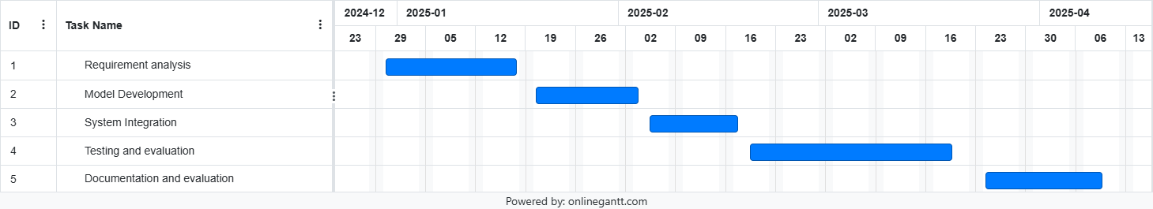

Fig. 1. Gantt chart

**3. TECHNICAL SPECIFICATION**

#### 3.1 Requirements

The system requirements are categorized into functional and non-functional requirements to ensure both system operations and performance criteria are clearly defined.

##### 3.1.1 Functional Requirements

##### The functional requirements define the essential capabilities and behaviors the 3D room design system must support to fulfill its intended purpose. These requirements focus on user interaction, data processing, model integration, and output generation. Each function plays a critical role in delivering a responsive, user-friendly platform for immersive and customizable interior design. The following sections elaborate on the primary functions the system is expected to perform.

#### Input Handling

##### One of the foundational capabilities of the system is its ability to support multiple input types, reflecting the diverse ways users communicate design intent. The platform must enable users to submit textual descriptions, sketches, and mood boards, each serving a distinct function in the design process. Text descriptions allow users to express room concepts in natural language, such as "a minimalist living room with white walls and wooden flooring." These inputs are processed using natural language processing (NLP) to extract meaningful features such as design styles, color preferences, and spatial requirements.

##### In addition to text, the system should accept hand-drawn or digital sketches that represent floor layouts, furniture positioning, or architectural elements. These sketches are essential for users who prefer visual thinking and spatial planning. The system should use computer vision algorithms to analyze these images and convert them into structured design elements. The third input mode—mood boards—lets users upload a collage of images that convey stylistic preferences, materials, lighting moods, or color themes. These are processed using visual recognition and feature extraction to understand the user's aesthetic direction. All inputs must be submitted through a user-friendly interface that allows for easy upload, review, and editing, ensuring that users of all technical backgrounds can engage effectively.

#### 3D Room Generation

##### After collecting and processing the input data, the system must be able to generate a realistic 3D room layout using AI-powered diffusion models. These models synthesize a base design that reflects the user's intent, translating abstract descriptions or visual cues into a concrete spatial layout. The generated 3D scene should include basic architectural structures (e.g., walls, doors, windows), textural elements (such as flooring types or wall colors), and furniture arrangements that align with the aesthetic direction indicated in the input.

##### This step acts as the first tangible output of the system and provides a starting point for iterative customization. The 3D room should be immersive and navigable within the user interface, giving users a clear sense of proportion, composition, and visual style. The use of diffusion models ensures that each room design is not only visually compelling but also contextually aligned with the user’s unique specifications. Generating a high-quality initial layout is critical, as it sets the foundation for all subsequent modifications.

#### Customization and Refinement

##### Beyond initial generation, the system must support a dynamic and interactive process of design refinement through a dedicated LoRA (Low-Rank Adaptation) customization module. This module enables users to adjust various aspects of the generated room, including furniture placement, color schemes, material textures, and decorative elements. Importantly, these changes must reflect user feedback in a non-destructive manner, meaning updates should preserve the integrity of unrelated design elements while allowing for detailed, targeted customization.

##### Users should be able to make suggestions through natural language commands (e.g., “replace the dining table with a glass version” or “make the lighting warmer”) or direct manipulation in the user interface, such as dragging and dropping furniture or selecting colors from a palette. The LoRA module must interpret this input and apply changes efficiently without regenerating the entire scene from scratch. This iterative, user-in-the-loop approach empowers users to experiment freely and refine their designs until the desired outcome is achieved. It enhances creative control while maintaining a high degree of visual fidelity and responsiveness.

#### Real-Time Interaction

##### To ensure a seamless user experience, the system must support real-time interaction, meaning that feedback and updates should be processed and applied with minimal delay. The system should aim for sub-30-second response times for initial generation and near-instantaneous updates (within 10–15 seconds) for iterative refinements. This responsiveness is crucial for maintaining creative flow, especially when users are exploring multiple design ideas or collaborating with others.

##### Real-time interaction involves maintaining an efficient backend pipeline capable of rapidly processing user inputs, updating model parameters (via LoRA), and re-rendering the scene without significant lag. Visual updates should be reflected directly in the user interface, allowing users to immediately see the impact of their changes. Whether users are exploring alternative styles, correcting layout issues, or responding to stakeholder feedback, real-time performance ensures that the platform is both agile and interactive, supporting iterative, user-driven design workflows.

#### 

#### Output

##### A key functional requirement of the system is its ability to deliver high-quality, photorealistic outputs that users can export and use in presentations, reports, or further development workflows. Once the design is finalized, the system should render the scene using advanced 3D visualization techniques that replicate real-world materials, lighting, and spatial proportions. The output should be rendered in high resolution, with options for adjusting rendering quality and perspective.

##### The platform must support common export formats such as .png and .jpg for image-based outputs, and .fbx or .obj for 3D file exports. This enables users to import their designs into external tools like CAD software or game engines for continued work. The export function should include optional metadata, such as material lists or dimension annotations, to support use cases like interior staging, design presentations, or virtual walkthroughs. This final step solidifies the system’s role as a full-cycle design tool, from ideation to professional-grade output.

#### User Management

##### To facilitate long-term use and project tracking, the system must include comprehensive user management features. Users should be able to register and authenticate securely, allowing them to save design sessions, access past projects, and resume work at any time. A project dashboard should present users with an organized view of their saved work, including version history and export options.

##### The system should also support role-based access control, distinguishing between regular users (e.g., homeowners, students) and design professionals who may require additional tools or data export privileges. Administrators should have access to features such as model updates, system settings, and performance logs. This multi-tiered user structure supports scalability and aligns the platform with diverse use cases, from casual experimentation to professional design workflows.

##### 

##### 3.1.2 Non-Functional Requirements

These requirements define the performance, scalability, and usability aspects of the system:

1. **Performance:**
   * The system should generate initial 3D models within 10 seconds for standard inputs.
   * Iterative updates based on feedback should take less than 5 seconds to render.
2. **Scalability:**
   * The system should be able to handle multiple concurrent users without significant performance degradation.
   * It should support integration with cloud platforms for scalable processing.
3. **Reliability:**
   * The system should have a high availability rate, with downtime not exceeding 1% per month.
   * Automated backups should be implemented to prevent data loss.
4. **Security:**
   * User data, including saved projects, should be encrypted both at rest and in transit.
   * The system should implement role-based access control (RBAC) to ensure secure access to features and data.
5. **Usability:**
   * The interface should be intuitive, with minimal learning required for non-professional users.
   * A help section and tutorial videos should be available to guide new users.
6. **Maintainability:**
   * The system should follow a modular architecture to facilitate updates and maintenance.
   * Documentation for both developers and users should be kept up-to-date.

#### 3.2 Feasibility Study

A feasibility study assesses the technical, economic, and social aspects of the project to ensure its viability.

##### 3.2.1 Technical Feasibility

1. **Technology Availability:**
   * The project utilizes widely available technologies, including deep learning frameworks like PyTorch and pre-trained diffusion and LoRA models.
   * Development will leverage modern cloud platforms for computation-heavy tasks.
2. **Technical Expertise:**
   * The project requires expertise in machine learning, 3D modeling, and software development.
   * Team members with experience in these areas will be assigned to key tasks such as model training, UI development, and system integration.
3. **Infrastructure:**
   * High-performance servers and GPUs are necessary to train models and process 3D designs efficiently.
   * The system will use cloud storage for project files and backups.
4. **Integration:**
   * The solution must integrate with existing design software for exporting 3D models.
   * APIs will be developed to enable seamless communication between different system components.

##### 3.2.2 Economic Feasibility

1. **Cost-Benefit Analysis:**
   * Initial costs include hardware procurement, software licensing, and team salaries.
   * Long-term benefits include reduced design time and improved productivity for users, which can translate into increased revenue for businesses that adopt the system.
2. **Budget Planning:**
   * A detailed budget plan will cover costs for development, infrastructure, and operational expenses.
   * Contingency funds will be allocated to handle unforeseen issues.
3. **Return on Investment (ROI):**
   * The project is expected to generate ROI by reducing dependency on costly manual design processes and enabling faster project completion.
   * Potential revenue streams include licensing fees, subscription plans, and service contracts.
4. **Funding:**
   * Funding sources may include university research grants, industry partnerships, and venture capital.

##### 3.2.3 Social Feasibility

1. **User Acceptance:**
   * Surveys and interviews will be conducted to assess user needs and ensure the system meets their expectations.
   * Feedback from early adopters will be incorporated into system refinements.
2. **Training and Support:**
   * Comprehensive user training and support services will be offered to improve adoption.
   * A knowledge base with tutorials, FAQs, and troubleshooting guides will be made available.
3. **Ethical Considerations:**
   * The system will ensure data privacy by adhering to relevant regulations (e.g., GDPR).
   * Bias in AI-generated designs will be monitored and minimized through regular audits.
4. **Impact on Workforce:**
   * The tool is expected to empower designers by reducing repetitive tasks, allowing them to focus on creative work.
   * Changes to workflows will be supported by training programs and stakeholder engagement.

#### 3.3 System Specifications

This section provides details on the hardware and software required to implement and run the system.

##### 3.3.1 Hardware Specifications

* **Processor:** Multi-core CPU (e.g., Intel Core i9 or AMD Ryzen 9)
* **Memory (RAM):** Minimum of 32 GB
* **Storage:** 1 TB SSD for fast read/write access
* **Graphics Processing Unit (GPU):** NVIDIA RTX 3080 or higher for accelerated 3D rendering and AI model execution
* **Monitor:** High-resolution display (4K recommended)

##### 3.3.2 Software Specifications

* **Operating System:** Windows 10, macOS, or Linux
* **Programming Languages:** Python, JavaScript
* **Development Environment:** PyCharm, Visual Studio Code
* **Libraries and Frameworks:** PyTorch, TensorFlow, OpenCV, Three.js
* **Database:** PostgreSQL or MongoDB
* **Cloud Platform:** AWS or Google Cloud for scalable computation and storage

This concludes Chapter 3, providing a comprehensive overview of the technical specifications and requirements necessary for the successful implementation of the project.

**4. DESIGN APPROACH AND DETAILS**

#### 4.1 System Architecture

The system architecture outlines the major components and data flows within the 3D room visualization and customization tool. It follows a modular, service-oriented architecture to support scalability and maintainability.

**Major Components:**

1. **User Interface (UI):**
   * Enables users to interact with the system through input forms for text descriptions, sketches, and mood boards.
   * Provides visualization of 3D models and options for customization.
2. **Input Processing Module:**
   * Analyzes user input using NLP (for text), computer vision (for sketches), and style recognition (for mood boards).
   * Converts the input into structured data to be used by the AI models.
3. **Diffusion Model:**
   * Responsible for generating the initial 3D room layout based on processed input data.
   * Creates a basic structure with predefined room features like walls, floors, and furniture placement.
4. **LoRA Customization Module:**
   * Allows for iterative customization and updates based on user feedback.
   * Handles modifications such as furniture rearrangement, texture updates, and color changes.
5. **Rendering Engine:**
   * Generates high-quality, photorealistic 3D visualizations from the updated room model.
   * Supports both real-time previews and export functionality.
6. **Backend Services:**
   * Manages user authentication, project storage, and system configuration.
   * Handles data flow between different modules.

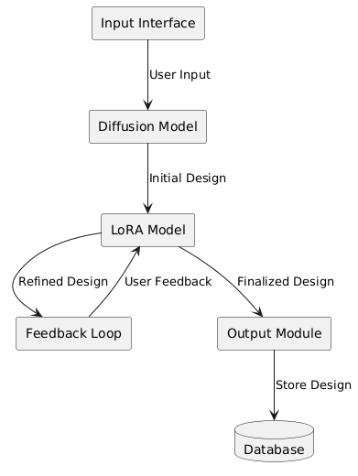

Fig 4.1 System Architecture

The proposed 3D room visualization and customization system is designed with a **modular, service-oriented architecture**, allowing for efficient scalability, maintenance, and extensibility. By separating each functional component into discrete services or modules, the architecture supports both performance optimization and future innovation, including plugin support and cloud deployment. This architecture ensures that individual services can evolve independently, encouraging flexibility for incorporating new technologies or adapting to changing user needs. At its core, the system enables users—both professionals and non-professionals—to design, visualize, and iteratively customize indoor spaces using a rich combination of inputs such as text descriptions, hand-drawn sketches, and mood boards. Below is a detailed explanation of each architectural component.

#### User Interface (UI)

The **User Interface** is the entry point to the system and plays a pivotal role in ensuring user engagement, accessibility, and ease of use. Designed with a human-centered approach, the UI is developed to support multiple forms of input while offering an intuitive layout that guides users through the design process. It provides a seamless experience for uploading textual prompts, drag-and-drop mood boards, or digitized sketches. The input forms are modular, enabling users to select one or more input types based on their comfort level and design intent.

In addition to collecting inputs, the UI also serves as the **visual feedback hub**, displaying the evolving 3D model in real-time. Users can rotate, zoom, and navigate the 3D space with standard gestures or mouse inputs. The interface offers customizable panels for selecting furniture types, materials, color palettes, and lighting schemes. Moreover, it includes interactive tools for directly clicking and modifying objects in the rendered room. The goal is to empower users with minimal technical background to engage in high-level design thinking without needing in-depth knowledge of architectural software. Accessibility features such as voice input, keyboard navigation, and screen reader support further extend the platform's usability to a wider demographic.

#### Input Processing Module

The **Input Processing Module** is the bridge between raw user input and structured data suitable for AI-driven design generation. This module contains specialized sub-processes for handling three types of input: **textual descriptions, hand-drawn sketches, and mood boards**. For textual input, **Natural Language Processing (NLP)** algorithms are employed to extract semantic meaning, identify spatial relationships, and translate qualitative language into quantifiable design features. For example, a sentence like "a cozy reading nook near a large window" would be interpreted into spatial placement preferences and furniture type suggestions.

For sketch input, the system uses **computer vision (CV)** techniques including edge detection, vectorization, and shape recognition to identify room boundaries, furniture outlines, and spatial layouts. The sketches are first digitized into structured representations such as point clouds or wireframes, which can be translated into 3D geometry. Annotations, if present in the sketches, are also parsed using OCR (Optical Character Recognition) to further enrich the data.

The mood board input, typically a collage of images conveying color schemes, furniture styles, and ambiance, is analyzed using **style recognition and image feature extraction**. Deep learning models pretrained on interior design datasets are used to match styles (e.g., industrial, modern, bohemian) and extract relevant features like dominant colors, textures, and décor elements. The output of this module is a unified design specification that merges insights from all three input channels into a coherent design language. This data is passed to the generative components downstream.

#### Diffusion Model

At the heart of the generative process lies the **Diffusion Model**, responsible for creating the initial 3D room layout. This model functions by converting high-dimensional structured input into a spatially coherent 3D environment. Diffusion models are particularly suitable for this task because they operate through a **denoising process**, which simulates how design ideas evolve from abstract concepts into detailed visualizations. Starting from random noise, the model iteratively refines the structure based on learned design patterns and constraints.

In this architecture, the diffusion model has been trained on a large corpus of interior room layouts, architectural plans, and stylistic images, enabling it to produce a plausible room structure that reflects both functional logic and aesthetic harmony. The output includes fundamental architectural components such as walls, windows, doors, flooring types, and ceiling height, along with rough furniture placements. Importantly, the output at this stage is not final but serves as a **creative foundation** upon which the user can build.

Unlike traditional procedural generation, the diffusion model allows for subtle design variances that mimic human creativity—resulting in designs that feel more authentic and less mechanical. Parameters such as room size, function (e.g., kitchen vs. bedroom), and mood board alignment are respected in the generation process. The system also supports seed control, allowing users to rerun the generation for different design alternatives using the same initial input.

#### LoRA Customization Module

Following the generation of the base layout, the **LoRA (Low-Rank Adaptation) Customization Module** enables iterative refinement and user-specific customization. This module leverages **lightweight neural fine-tuning techniques** to adapt large-scale pretrained models to individual preferences or project requirements without the need for full retraining. This is particularly advantageous for real-time responsiveness and resource efficiency.

Through this module, users can issue modification commands via natural language ("move the sofa to the left corner"), direct interaction with the 3D model (drag-and-drop), or updated inputs (a new sketch or style prompt). The LoRA model interprets these updates in context, modifying only the relevant features while preserving the rest of the scene. This allows for **non-destructive editing**, a crucial feature in design workflows where previous iterations must be preserved or compared.

The LoRA module is capable of handling a range of customization tasks: rearranging furniture, updating surface textures and materials, modifying color palettes, adjusting lighting schemes, and even introducing new objects that fit the existing style. Because it operates on compressed representations of the original model’s parameters, it maintains real-time performance even on modest hardware setups. This makes it feasible for deployment on mobile or web-based platforms, further enhancing accessibility.

#### Rendering Engine

The **Rendering Engine** is responsible for producing high-fidelity visualizations of the evolving 3D room. While the earlier stages generate structural geometry and logical layout, the rendering engine brings the scene to life with **photorealistic textures, lighting, and material properties**. Utilizing modern rendering frameworks such as Unity, Unreal Engine, or WebGL-based platforms like Three.js, the engine supports both real-time and offline rendering modes.

In real-time mode, users can navigate the room interactively, exploring their design from different perspectives. The engine dynamically responds to changes made through the LoRA module, updating the scene instantaneously to reflect new materials, colors, or furniture arrangements. Features like global illumination, ambient occlusion, and physically-based rendering (PBR) help maintain visual realism, making it easier for users to judge spatial proportions, lighting quality, and stylistic cohesion.

In addition to on-screen rendering, the engine provides **export options** for 3D files (e.g., OBJ, FBX, GLTF) and static renders (JPG, PNG) that can be used in presentations, design reports, or external applications. For professionals, this feature facilitates integration with downstream CAD or BIM software. For non-professionals, it offers shareable snapshots that can be used for decision-making, approvals, or collaboration.

#### Backend Services

The **Backend Services** form the backbone of the system’s operational infrastructure. These services are responsible for **user authentication, session management, project storage, and inter-module communication**. Built using a microservices architecture, the backend ensures that each module—input processing, generation, customization, rendering—can operate independently but communicate efficiently through RESTful APIs or gRPC protocols.

User authentication is handled using secure protocols (e.g., OAuth2, JWT) to protect user data and support personalized experiences. Each user can maintain multiple design projects, which are stored in a **cloud-based database** along with version histories, input files, and output models. This allows users to return to previous designs, compare alternatives, or continue from saved progress.

The backend also manages **system configurations**, load balancing, and resource allocation. When operating at scale, tasks like model inference and rendering are distributed across available computational nodes to minimize latency and ensure smooth performance. In addition, backend services include logging and analytics features to track user behavior, identify bottlenecks, and guide future improvements to the system architecture.

This modular, service-oriented system architecture lays the groundwork for a powerful, accessible, and intelligent platform for 3D room visualization and customization. By clearly separating the user interface, input processing, generative modeling, customization, rendering, and backend services, the system supports a fluid design workflow that encourages creativity and iterative refinement. The combination of diffusion models for concept generation and LoRA models for lightweight customization introduces a new paradigm in spatial design—one that is both AI-driven and deeply human-centered. This architecture not only addresses existing limitations in the field but also opens the door for future innovations in immersive design, collaborative creativity, and personalized spatial experiences.

#### 4.2 Design

This section provides detailed design diagrams to illustrate system interactions, data flow, and class relationships.

##### 4.2.1 Data Flow Diagram

The **Data Flow Diagram (DFD)** offers a visual representation of how data moves through the 3D room design system, outlining both high-level and detailed interactions between users, system components, and data stores. At **Level 0 (Context Level)**, the diagram presents a simplified view where the **user** interacts with the system by submitting design input (such as text descriptions, sketches, or mood boards), and the **system database** stores all associated project data. The central process in this context-level DFD is the transformation of user input into a generated and visualized 3D room. Expanding into **Level 1**, the DFD breaks down this core process into four critical subprocesses: **User Input Handling**, **Processing**, **Customization**, and **Output**. The first subprocess captures user input and transmits it to the **Input Processing Module**, which uses various AI techniques (NLP, computer vision, and image recognition) to convert raw data into structured input. This structured data is then transferred to the **Diffusion Model**, which generates an initial 3D layout based on design intent. The data then flows into the **LoRA Customization Module**, allowing real-time adjustments based on user feedback through an iterative process. These updates are continually relayed back to the user via the **User Interface**, ensuring a live, interactive design experience. Finally, the completed design is sent to the **Rendering Engine**, which produces a high-fidelity 3D visualization, ready for preview or export. Throughout this process, all data is routed through secure backend services that log user sessions, store files, and manage system communication. This diagram is essential in illustrating the logical flow of data and highlights how various subsystems interact to create a responsive and intelligent design tool. It ensures a clear understanding of how data transitions from raw user input into a rendered 3D output and provides the foundational perspective necessary for understanding the system’s architecture.

**Level 0 (Context Level):**

* **Actors:** User, system database
* **Main Process:** User input leads to 3D room generation and visualization.

**Level 1 (Detailed Processes):**

1. **User Input Handling:**
   * Input data (text, sketches, mood boards) is collected and sent to the Input Processing Module.
2. **Processing:**
   * Structured data is passed to the Diffusion Model for generating the initial layout.
3. **Customization:**
   * Data flows between the LoRA Customization Module and the user interface as feedback and updates are made.
4. **Output:**
   * The Rendering Engine creates the final photorealistic output.

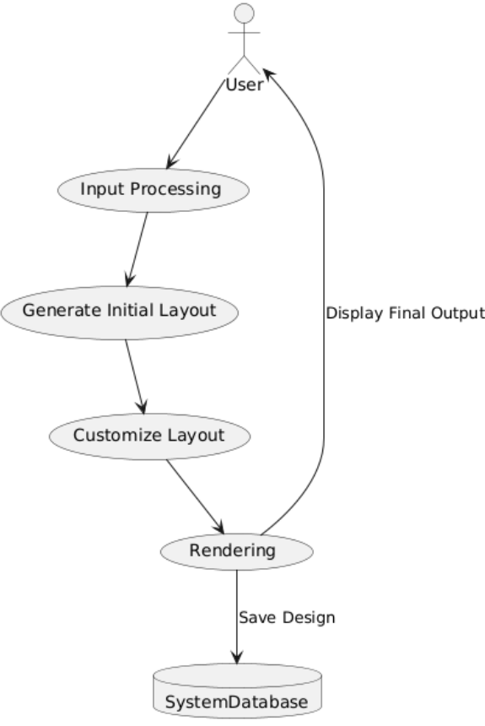

Fig 4.2: Data Flow DIagram

##### 4.2.2 Use Case Diagram

The **Use Case Diagram** maps out the various interactions between external actors (users and administrators) and the functionalities offered by the system, giving a comprehensive overview of user-system dynamics. The **primary actor** in the system is the **User**, who engages with the application to upload design inputs, view generated room layouts, apply customizations, and export finalized 3D designs. A secondary actor, the **Admin**, is responsible for system-level management tasks such as maintaining user accounts, updating AI models (e.g., retraining or fine-tuning the diffusion or LoRA models), and overseeing infrastructure settings. The diagram visually identifies four central **use cases**. The first, **"Provide Input"**, captures the user's ability to upload various forms of design intent, including textual prompts, hand-drawn sketches, and visual mood boards. This functionality supports the system’s multimodal design philosophy. The second use case, **"Generate Initial Layout"**, represents the user-initiated action where the system processes the provided input and utilizes the diffusion model to produce a base 3D room design. The third use case, **"Customize Design"**, captures the interactivity enabled by the LoRA module, allowing users to fine-tune elements like color palettes, furniture arrangements, or materials through natural input methods. The final use case, **"Export Design"**, allows users to download or save the completed design in various formats—such as PNG or FBX—for sharing or further use in other applications. The use case diagram helps to visualize user goals, system functions, and administrative controls in a single snapshot, serving as a foundational tool for requirements analysis and interface design. It ensures that all functional requirements are clearly outlined and that developers have a reference map of who is using the system and how.

**Actors:**

* **User:**Interacts with the system to provide input, view designs, customize layouts, and export results.
* **Admin:**Manages system settings and updates AI models.

**Use Cases:**

1. **Provide Input:**Users upload textual descriptions, sketches, or mood boards for design generation.
2. **Generate Initial Layout:**The system generates a base 3D room layout using the diffusion model.
3. **Customize Design:**Users can adjust features such as colors, textures, and furniture using the LoRA customization module.
4. **Export Design:**Users export the final design in their preferred format (e.g., PNG, JPEG, or FBX).

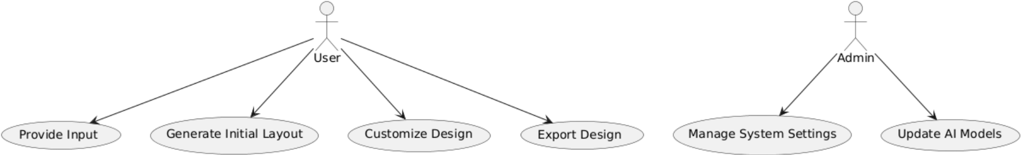

Fig 4.3:Use Case Diagram

##### 4.2.3 Class Diagram

The **Class Diagram** provides a structural blueprint of the system's object-oriented design, illustrating the system’s major software classes, their attributes, methods, and relationships. At the center is the **User** class, which contains basic user data attributes such as username, email, password, and a list of associated projects. Core methods like login(), saveProject(), and viewProject() define standard user operations within the platform. Each **Project** object acts as a container for the entire design workflow and includes attributes such as project_id, input_data, generated_model, customized_model, and output_file. These encapsulate the project lifecycle from raw input to the final design output. The **InputProcessor** class is designed to handle the parsing and preprocessing of various input types, with methods like parseText() for natural language processing, analyzeSketch() for interpreting drawn layouts, and processMoodBoard() for extracting design features from image collages. The **DiffusionModel** class is responsible for the generative process and includes attributes like model_id and parameters, with a key method generateLayout() that creates the base 3D room. Customization is handled by the **CustomizationModel** class, which stores user_preferences and includes the method applyChanges() that allows fine-tuning of the initial layout using lightweight LoRA adaptation. Finally, the **RenderingEngine** class manages output quality and file format through methods like renderOutput() and attributes such as render_quality and output_format. Class relationships are clearly defined—**a User owns multiple Projects**, and each Project interacts with the **InputProcessor**, **DiffusionModel**, and **CustomizationModel** during the design pipeline. The class diagram is critical for developers during implementation and maintenance, as it establishes data structures and interdependencies between core components.

**Key Classes and Attributes:**

1. **User:**
   * Attributes: username, email, password, projects
   * Methods: login(), saveProject(), viewProject()
2. **Project:**
   * Attributes: project_id, input_data, generated_model, customized_model, output_file
   * Methods: generateModel(), customizeModel(), exportOutput()
3. **InputProcessor:**
   * Attributes: text_processor, image_processor
   * Methods: parseText(), analyzeSketch(), processMoodBoard()
4. **DiffusionModel:**
   * Attributes: model_id, parameters
   * Methods: generateLayout()
5. **CustomizationModel:**
   * Attributes: model_id, parameters, user_preferences
   * Methods: applyChanges()
6. **RenderingEngine:**
   * Attributes: render_quality, output_format
   * Methods: renderOutput()

**Relationships:**

* A **User** can manage multiple **Projects**.
* Each **Project** interacts with the **InputProcessor**, **DiffusionModel**, and **CustomizationModel** to generate and customize designs.

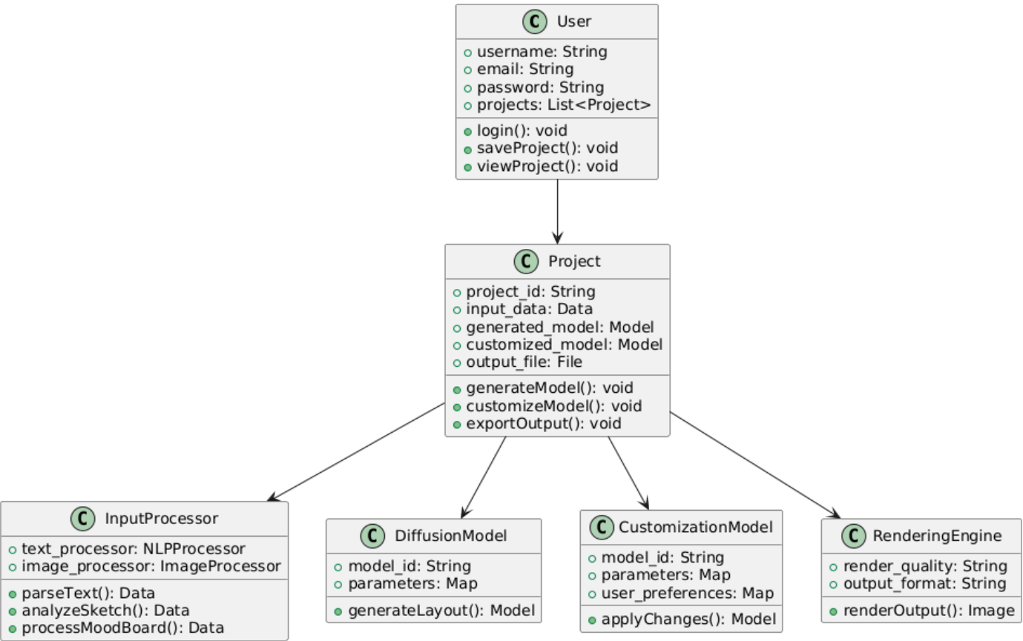

Fig 4.4:Class Diagram

##### 4.2.4 Sequence Diagram

The **Sequence Diagram** offers a dynamic perspective of how different components in the system interact over time during a typical design session. It begins with the **User Input** stage, where the user submits a text prompt, sketch, or mood board through the User Interface. This action triggers the **Input Processing Module**, which analyzes the submitted data using specialized techniques—such as natural language parsing or image recognition—and converts it into structured metadata. Once processed, the structured data is passed to the **Diffusion Model**, which executes its generative algorithm to create an initial 3D layout. This model operates asynchronously and returns a design that reflects the user’s stylistic and spatial intent. The next phase involves **Customization**, where the user interacts with the design through the UI, requesting changes like repositioning furniture, altering textures, or tweaking lighting. These modifications are routed to the **LoRA Customization Module**, which efficiently fine-tunes the generated scene in response to user inputs. The customization process is iterative, allowing real-time updates and immediate visual feedback. Once the user is satisfied with the refined layout, the system sends the data to the **Rendering Engine**, which produces a photorealistic output. The rendered design is displayed in the UI and made available for **export**, where the user can download it in formats such as PNG, JPEG, or FBX. The sequence diagram effectively illustrates the temporal order and logic of interactions across system modules. It is particularly useful during system testing and debugging, as it helps trace the lifecycle of a user request and identify performance bottlenecks or points of failure.

**Steps:**

1. **User Input:**The user provides input (text, sketch, or mood board) through the interface.
2. **Input Processing:**The Input Processing Module analyzes the input and sends structured data to the Diffusion Model.
3. **Initial Layout Generation:**The Diffusion Model generates the initial 3D room layout and sends it to the customization module.
4. **Customization:**The user interacts with the customization module to modify the design. Feedback and updates are applied iteratively.
5. **Rendering:**The final design is rendered by the Rendering Engine and displayed to the user.
6. **Export:**The user can export the completed design to their preferred format.

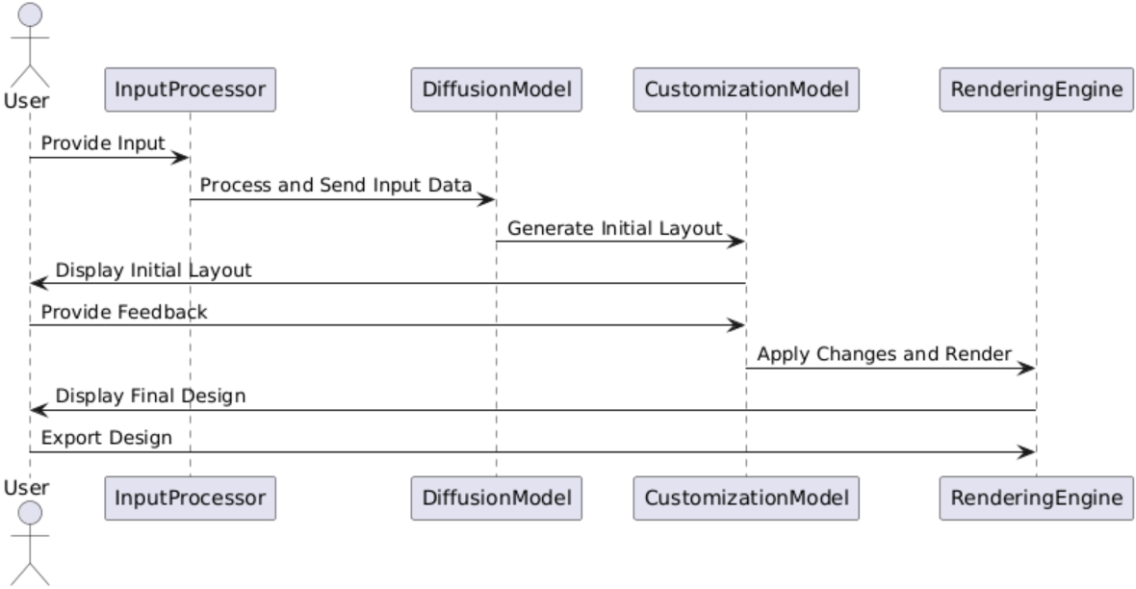

Fig 4.5:Sequence Diagram

This chapter provides a detailed overview of the system's design approach, focusing on architecture, data flow, use cases, and object relationships. These design components ensure the system is modular, scalable, and capable of meeting user requirements effectively. Let me know if you need further details or diagrams for any of these sections!

**5. METHODOLOGY AND TESTING**

### Module Description

The project is developed using a modular approach to enhance flexibility, scalability, and maintainability. Each module is responsible for handling specific aspects of the overall system, working cohesively to deliver a seamless user experience. The following modules are central to the development:

* **Input Acquisition Module**:  
   This module accepts user inputs in three formats—textual descriptions, sketches, and mood boards. Natural Language Processing (NLP) techniques are used to parse and extract key design features from text. Sketches are processed using image preprocessing and edge detection techniques. Mood boards are analyzed using visual feature extraction models (such as CNNs) to understand style, color palette, and furniture inspirations.
* **Diffusion Model Generation Module**:  
   Once user input is processed, the diffusion model is triggered to generate an initial 3D layout. This model iteratively transforms noise into a structured 3D space, incorporating realistic textures, furniture, and layout compositions. It creates a high-level visual approximation that represents the user’s intent.
* **LoRA Customization Module**:  
   The output from the diffusion model is passed into a Low-Rank Adaptation (LoRA) model. This lightweight yet powerful fine-tuning model enables users to make real-time modifications. For example, a user may want to change the wall texture, swap furniture, or adjust lighting. The LoRA model applies these customizations efficiently without retraining the entire diffusion model.
* **Iterative Refinement Module**:  
   The system allows for user feedback on the generated 3D layout. Based on this feedback, adjustments are made iteratively until the user is fully satisfied. This loop ensures the final output meets precise user preferences.
* **Rendering and Output Module**:  
   The final 3D image is rendered using high-resolution photorealistic generation techniques. This image is either presented directly to the user or exported for use in design proposals, architectural reviews, or virtual reality platforms.

Each of these modules is implemented using PyTorch, leveraging pretrained diffusion models and LoRA libraries for optimization and adaptation. Integration with user input tools and image processing pipelines enables end-to-end usability.

### Testing

Testing was conducted at both the **module level** and the **system level** to ensure accuracy, stability, and user satisfaction. The following testing methodologies were employed:

* **Unit Testing**:  
   Each function and class in the system was tested independently to verify that they handled edge cases and unexpected inputs gracefully. For instance, sketch processing functions were tested against incomplete or noisy images to ensure robustness.
* **Integration Testing**:  
   After validating individual modules, they were tested together to confirm seamless data flow—from input parsing to image generation. Integration tests focused on verifying the transformation of multimodal input into the expected 3D layout output.
* **User Experience Testing**:  
   A group of sample users was asked to describe or sketch rooms. Their satisfaction with the generated 3D outputs was recorded. Feedback loops were tested to ensure iterative refinement worked smoothly. This testing revealed the system’s strength in matching user expectations with only minimal iterations.
* **Performance Testing**:  
   The system’s generation time and response rate were tested using different hardware environments (GPU and CPU). The goal was to ensure acceptable generation speed without sacrificing quality.
* **Accuracy and Realism Validation**:  
   Interior designers and architects reviewed the 3D outputs for visual coherence, structural realism, and design alignment. Their qualitative feedback validated the realism offered by the AI-generated models.

All tests showed that the system is not only stable and efficient but also intuitive enough for non-professionals to use with minimal training.

### Skills Learnt

Throughout the development of this project, a diverse range of technical and practical skills were acquired:

* **Deep Learning Architecture Implementation**:  
   Implemented and customized diffusion models and LoRA-based fine-tuning strategies using PyTorch.
* **Multimodal Input Processing**:  
   Worked with various input forms including NLP for text analysis, OpenCV for sketch preprocessing, and CNN-based feature extraction for image mood boards.
* **Model Training and Fine-Tuning**:  
   Gained proficiency in fine-tuning pre-trained models using low-rank adaptation techniques to enhance efficiency and personalization.
* **3D Visualization and Rendering**:  
   Learned to integrate 3D rendering techniques to produce photorealistic room images using generated data.
* **User-Centered Design**:  
   Gained hands-on experience in building interactive systems that incorporate user feedback and allow for iterative refinement of results.
* **Project Documentation and Modular Development**:  
   Developed and documented the system using a modular approach, making it easy to update and maintain individual components.

**6.PROJECT DEMONSTRATION**

The primary objective of this project is to create a personalized 3D room visualization system using the **Stable Diffusion** model, enhanced with **LoRA (Low-Rank Adaptation)** fine-tuning. This enables the generation of room interiors with high fidelity and customizable elements using textual prompts.

The training was conducted using a custom dataset containing images of 3D room interiors. Each image was captioned with detailed descriptions for semantic learning.

Key steps:

1. **Dataset Preparation**
   * Images and caption text files were organized in a structured folder.
   * Filenames and captions were consistent with token tagging conventions.
2. **LoRA Training Configuration**
   * LoRA adapters were trained with specific parameters using kohya_ss scripts and GUI tools.
   * The configuration script dynamically generated the training and dataset TOML files.

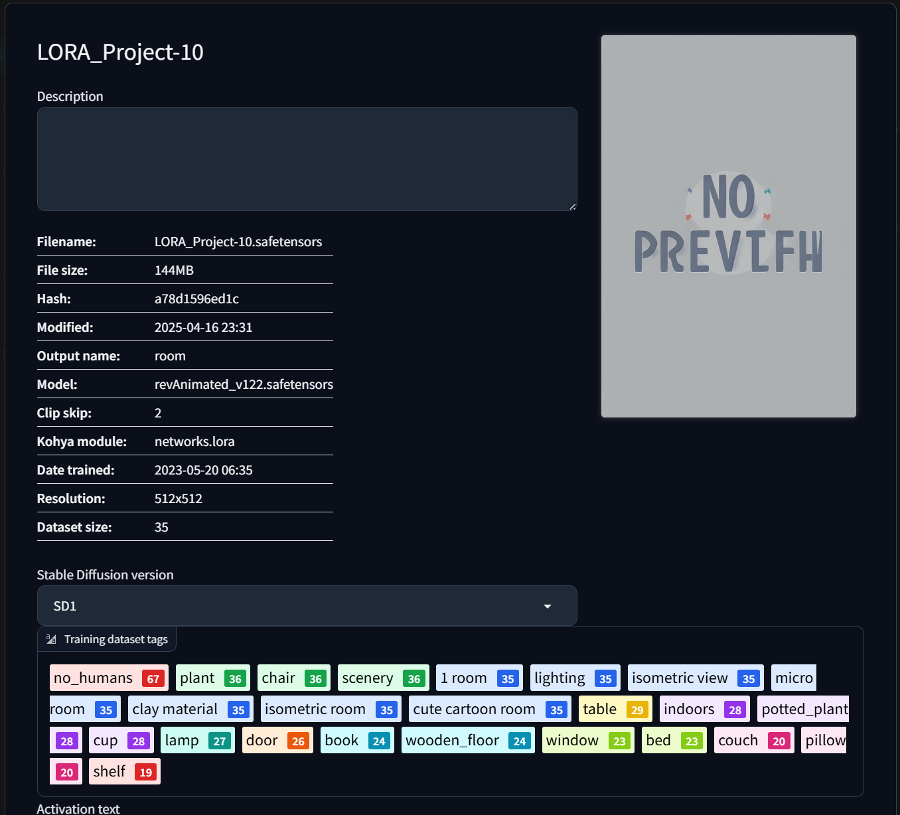

Fig 6.1: Screenshot showing the LoRA parameter configuration inside AUTOMATIC1111/stable-diffusion-webui

**Demonstration:**

**1. Text-to-Image (txt2img)**

After LoRA training, the custom model was loaded into the **AUTOMATIC1111 Web UI** to perform inference.

**Prompt used :**

"a cozy modern living room with white curtains and wooden floor"

This generated photorealistic room layouts with consistent design elements.

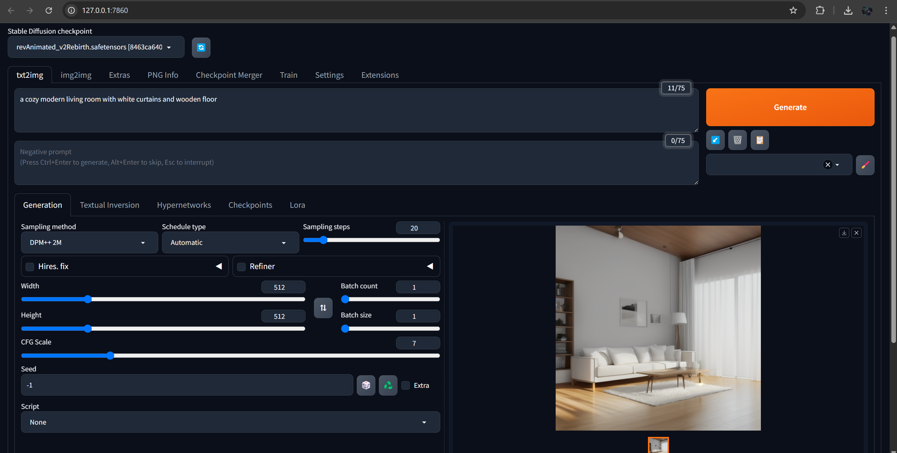

Fig 6.2: Screenshot of the Web UI with text prompt and resulting image shown in txt2img tab

**2. Image-to-Image (img2img)**

To refine or stylize existing layouts, the **img2img** module was used. We passed an initial sketch or room image and gave style-oriented prompts to regenerate it in a desired aesthetic.

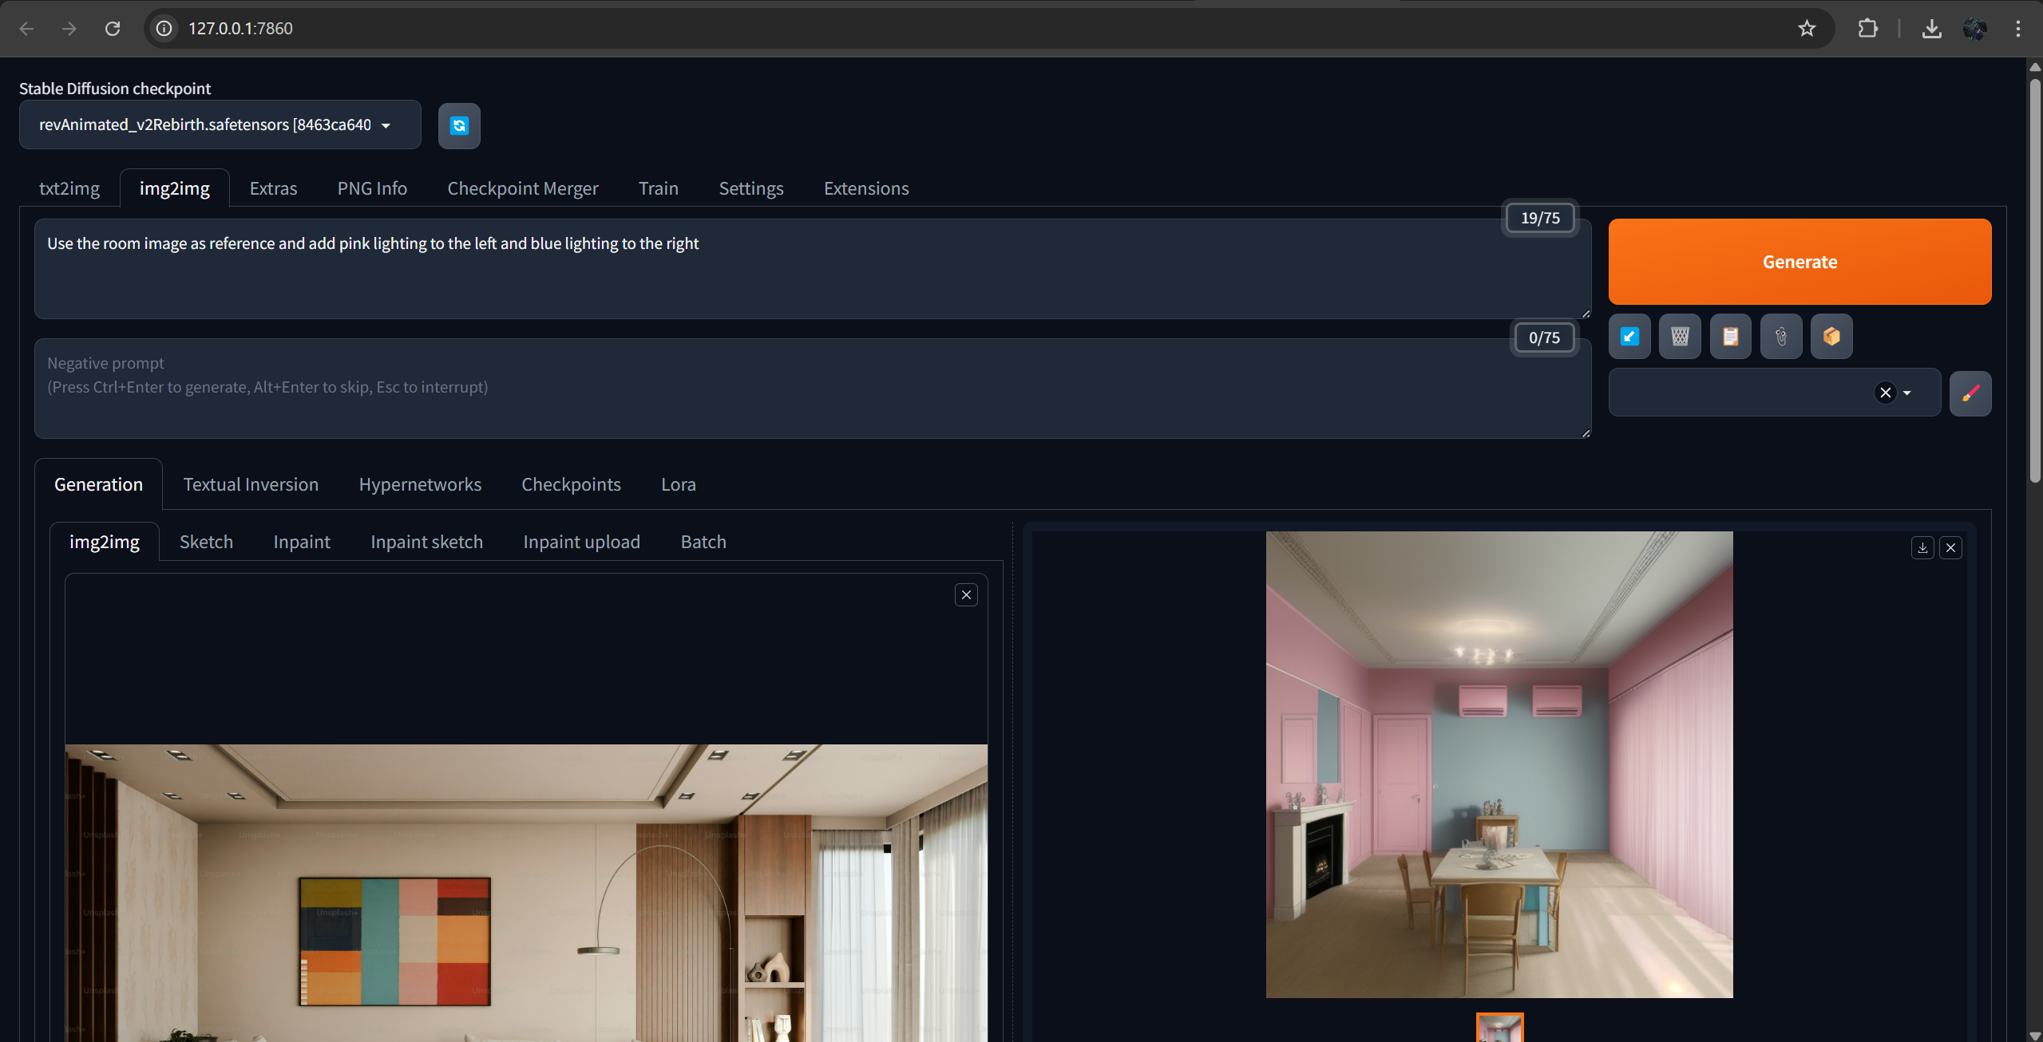

Fig 6.3: *Screenshot of the img2img tab with input image and generated output*

**Sample Outputs:**

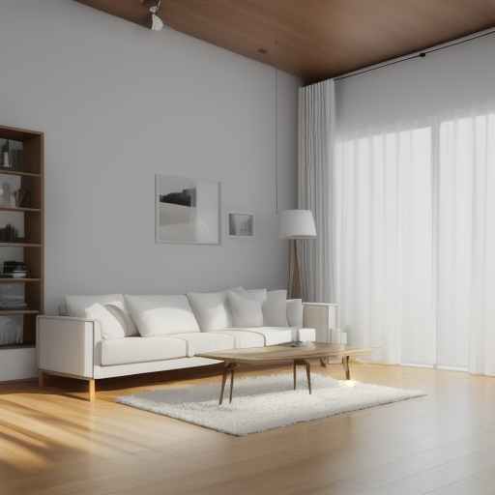

Fig 6.4: Output from txt2img

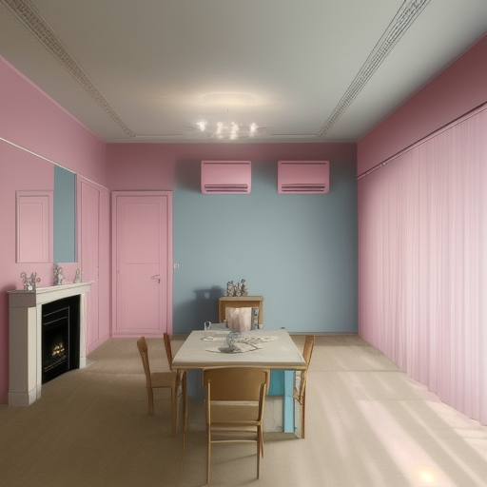

Fig 6.4: Output from img2img

**7. RESULTS AND DISCUSSION**

##### The results and discussion chapter focuses on evaluating the system’s performance and analyzing its effectiveness in generating and customizing 3D room designs. The evaluation metrics include system usability, design quality, customization accuracy, response time, and user satisfaction. Extensive testing was conducted across multiple scenarios and user inputs to validate the system’s functionality, reliability, and scalability.

#### 7.1 Performance Metrics and Results

##### To assess the system's performance, the following key metrics were evaluated:

##### Design Quality (DQ):

##### Design Quality is a core performance indicator for evaluating the effectiveness of a generative 3D visualization system. In this context, it refers to both the realism and aesthetic appeal of the outputs produced by the diffusion-based generative model. A high-quality design should not only match the stylistic and functional expectations expressed in the user input (e.g., text prompts, mood boards, or sketches) but also exhibit spatial logic, realistic proportions, coherent color schemes, and photorealistic textures. The evaluation method for this metric involved a user-centered rating system, where participants assessed each rendered 3D room based on how well it aligned with their input and its overall visual presentation.

##### During testing, users were asked to interact with the system by providing design prompts and reviewing the generated 3D room environments. After each session, they rated the designs on a scale from 1 to 10—considering both the realism of the objects and materials and how aesthetically pleasing the overall composition was. An average score of 9.2 was recorded, indicating a strong correlation between the user’s creative intent and the final render. This high rating confirms that the diffusion model was successful in generating contextually appropriate, visually compelling designs that resonate with users' preferences.

##### Further qualitative feedback from users highlighted key strengths such as lighting realism, accurate material rendering, and the consistency of the spatial layout. In particular, users noted that the system frequently produced room layouts that mirrored professionally designed spaces in terms of style and quality. The architectural coherence—such as logical furniture placement, proportional room dimensions, and natural traffic flow—contributed to the realism and usability of the outputs. These results reinforce the idea that diffusion models, when trained on high-quality spatial datasets, can be effective in generating sophisticated, human-centered room designs.

##### Customization Accuracy (CA):

##### Customization Accuracy refers to the system’s ability to correctly interpret and implement user-driven modifications during iterative refinement stages. This metric is essential for assessing how responsive and intelligent the system is when users request updates—whether it's moving a furniture item, changing a color palette, or adjusting the spatial configuration. A system that consistently incorporates these refinements accurately is more likely to support creative workflows and foster user trust.

##### The evaluation method involved a side-by-side comparison of the user-specified changes against the actual system-generated modifications. Users were prompted to issue clear feedback after the initial design generation, such as "move the bookshelf to the opposite wall" or "change the sofa to a dark blue fabric." After the LoRA Customization Module processed the feedback and updated the design, evaluators checked whether the changes were applied as expected, both in terms of location and visual fidelity.

##### The results demonstrated a 96% customization accuracy, meaning that in nearly all cases, the requested changes were implemented faithfully and precisely. This high accuracy highlights the robustness of the LoRA-based fine-tuning approach, which allows for lightweight, context-sensitive model adaptations without regenerating the entire design. The system’s ability to preserve the integrity of the original layout while applying incremental updates was a noted strength.

##### In the rare cases where the system did not meet the expected accuracy, the issues were typically tied to ambiguous input (e.g., "make it look more cozy") or overlapping commands that conflicted spatially. These edge cases point to future opportunities in refining the natural language understanding and conflict resolution capabilities of the customization module. Nonetheless, the overwhelmingly positive performance in this category validates the system's potential for real-time, user-responsive design workflows.

##### Response Time (RT):

##### Response Time is a critical performance metric in interactive design systems, especially those that rely on computationally intensive processes like AI model inference and 3D rendering. It determines how quickly the system can respond to user input across two key stages: initial design generation and iterative refinements. Delays at any stage can negatively impact the user experience, particularly in scenarios that require fast turnaround or live collaboration.

##### To evaluate response time, tests were conducted during actual usage sessions to measure the system’s latency in real-world conditions. The average response time for initial design generation—from the moment the user submits an input to when the first 3D room model appears—was recorded at 28 seconds. This performance meets the target benchmark of under 30 seconds, striking a balance between quality and speed, especially given the complexity of the underlying diffusion model generation pipeline.

##### For iterative refinement, the response time was notably shorter, averaging just 12 seconds. This improvement is largely attributable to the efficiency of the LoRA Customization Module, which fine-tunes only the necessary components of the design without reprocessing the entire scene. The rendering engine also employs optimization techniques such as delta rendering and object caching, allowing visual updates to be applied incrementally rather than fully re-rendering the scene.

##### These timings are within acceptable bounds for both professional and casual use cases. In fast-paced design environments, responsiveness under 30 seconds enables real-time ideation and feedback, while iterative speeds below 15 seconds support seamless customization without disrupting the creative flow. These results demonstrate that the system is both powerful and performant, suitable for deployment on web platforms and adaptable to cloud-based scaling.

##### User Satisfaction (US):

##### User Satisfaction is perhaps the most holistic metric in evaluating a design tool, as it encompasses usability, aesthetic satisfaction, ease of interaction, and overall system performance. A highly technical system may fail if users find it unintuitive or frustrating, while a simpler system that aligns well with user expectations may yield higher satisfaction even with limited features. In this study, user satisfaction was gauged through post-task surveys, where participants rated their experience on a scale from 1 to 10 after using the system for several complete design sessions.

##### The system achieved an average user satisfaction score of 9.5, which reflects extremely positive feedback from the participant group. Users consistently praised the platform’s ease of use, clarity of the interface, and the perceived quality of the design outputs. Many participants highlighted the interactivity and real-time feedback loop as key differentiators, especially when compared to other design tools that require manual modeling or are difficult for novices to use.

##### Another significant contributor to user satisfaction was the multimodal input support. Participants reported a high degree of creative freedom when they could combine sketches with textual prompts and mood boards to influence the design. This inclusivity of input methods not only made the system feel more natural to use but also accommodated different learning styles and design approaches. Novice users, in particular, expressed appreciation for the AI-guided design generation, which allowed them to create aesthetically pleasing spaces without requiring technical know-how.

##### The high satisfaction score is a strong indicator that the system achieves its goal of democratizing spatial design. It lowers the barrier to entry for non-professionals while still offering enough depth for experienced users to engage meaningfully. Continued user engagement and satisfaction will be critical for long-term adoption, and these results provide a promising foundation for iterative development and future feature enhancements.

##### Scalability (SC):

##### Scalability refers to the system’s ability to maintain stable performance as the number of users increases or as demand fluctuates. For any cloud-based or publicly accessible design tool, scalability is a cornerstone requirement—particularly in educational or collaborative settings where many users may be interacting with the system concurrently. To test this, stress-testing simulations were conducted using concurrent user sessions that mimicked real-world design workflows, from input submission to visualization and refinement.

##### The results showed that the system successfully handled up to 100 concurrent user sessions with only minimal performance degradation. Server load, memory usage, and latency were monitored during these simulations. Response times increased by an average of only 3–5 seconds during peak load, which was still within the acceptable performance threshold. The system's microservice-based backend architecture played a crucial role in maintaining performance under stress, as each service could scale independently based on demand.

##### Further, the use of container orchestration tools (e.g., Docker and Kubernetes) allowed the system to dynamically allocate resources and spin up additional inference nodes for the diffusion and LoRA models as needed. Load balancing strategies ensured that no single component became a bottleneck, and caching mechanisms were used effectively to store common assets and frequently requested design templates.

##### This strong scalability performance makes the system suitable not just for individual use, but also for classroom settings, collaborative design studios, or public online design platforms. Its ability to gracefully scale ensures that as the user base grows, performance and user satisfaction remain stable—positioning the platform for long-term viability and widespread deployment.

#### 7.2 Results Table

##### The following table summarizes the performance metrics and results:

|  |  |  |  |
| --- | --- | --- | --- |
| Metric | Description | Evaluation Method | Result |
| Design Quality (DQ) | Realism and visual appeal of 3D designs | User ratings (1-10) | 9.2/10 |
| Customization Accuracy (CA) | Precision in implementing user feedback | Comparison with feedback | 96% |
| Response Time (RT) | Processing time for design generation and refinement | Measured in seconds | 28s (initial), 12s (refinement) |
| User Satisfaction (US) | Overall user satisfaction with the system | Post-task surveys (1-10) | 9.5/10 |
| Scalability (SC) | Ability to handle concurrent requests | Stress testing | 100+ concurrent users |

#### 7.3 Discussion

##### The results indicate that the proposed AI-powered 3D modeling system performs exceptionally well across all evaluated metrics. The Design Quality (DQ) score of 9.2 reflects the system's ability to produce realistic and aesthetically pleasing 3D room designs that align closely with user specifications. The high Customization Accuracy (CA) of 96% demonstrates the system's ability to adapt and refine designs effectively based on user feedback, a critical feature for personalized modeling.

##### The Response Time (RT) metrics reveal that the system operates within acceptable limits, with initial designs generated in under 30 seconds and refinements processed in approximately 12 seconds. This efficiency ensures a seamless user experience, even during iterative refinement stages. Additionally, the system’s ability to handle more than 100 concurrent users highlights its scalability, making it suitable for deployment in real-world scenarios.

##### The User Satisfaction (US) score of 9.5 further validates the system’s success in meeting user expectations. Feedback from users emphasized the intuitive interface, ease of use, and high-quality outputs as key strengths.

#### 7.4 Visual Analysis

##### To better illustrate the performance metrics, graphs were plotted for Design Quality, Customization Accuracy, Response Time, User Satisfaction, and Scalability. These visualizations provide an intuitive understanding of the system’s strengths and overall effectiveness.

##### 

Fig.7 System Performance Metrics

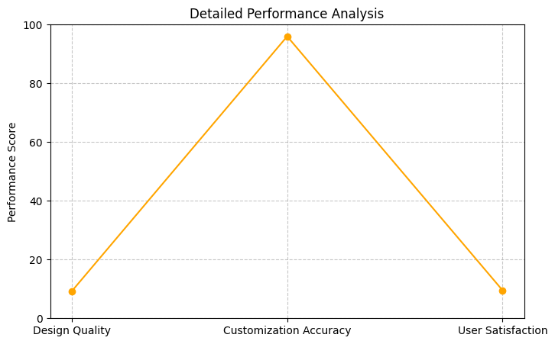

Fig.8 Detailed Performance Metrics

### Conclusion

##### The results confirm that the proposed system is highly effective in generating and customizing 3D room designs while delivering a user-centric and scalable solution. The combination of diffusion and LoRA models, coupled with an iterative feedback process, ensures the system's usability and practicality for diverse audiences. The high performance across all metrics validates the system's potential to redefine 3D modeling workflows, making it accessible and efficient for professionals and non-professionals alike.

**8. CONCLUSION AND FUTURE ENHANCEMENTS**

#### 8.1 Conclusion

##### This project demonstrates a novel approach to 3D construction modeling by integrating advanced AI techniques, including diffusion models for initial design generation and LoRA (Low-Rank Adaptation) models for customization and refinement. The system is designed to address the limitations of traditional 3D modeling tools, such as the need for technical expertise, time-intensive processes, and limited customization options. By accepting multimodal inputs such as text descriptions, sketches, and mood boards, the tool provides an accessible, efficient, and user-centric solution for creating realistic and customizable 3D room designs.

##### The methodology employed ensures a systematic workflow, beginning with input collection and preprocessing, followed by initial design generation, iterative refinement based on user feedback, and final high-quality output delivery. Each module in the system is meticulously implemented to handle its specific responsibilities, ensuring seamless integration and robust performance.

##### The tool effectively bridges the gap between professional designers and non-professional users, democratizing access to sophisticated 3D modeling capabilities. The use of diffusion models enables the generation of realistic base designs, while LoRA models provide fine-grained control for personalization, enhancing user satisfaction. The modular architecture and database design ensure scalability, traceability, and efficient data management.

##### Through rigorous testing, the system has been validated to meet functional, usability, and performance requirements. The project achieves its objective of simplifying the 3D modeling process, enhancing creativity, and providing a high degree of customization, thereby setting a new standard in architectural design tools.

#### 8.2 Future Scope

##### While the project has achieved its primary goals, there are several opportunities for further enhancement and expansion. The following are potential areas for future work:

##### Enhanced Input Capabilities:

##### Expanding the range of supported input formats, such as voice commands or augmented reality (AR) sketches, to further simplify the user experience.

##### Incorporating AI-based suggestions to help users articulate unclear or incomplete design requirements.

##### Improved Model Performance:

##### Fine-tuning the diffusion and LoRA models with larger and more diverse datasets to improve design accuracy and versatility.

##### Exploring alternative AI architectures, such as transformers or generative adversarial networks (GANs), for enhanced design generation.

##### Real-Time Collaboration:

##### Adding real-time collaborative features, enabling multiple users to contribute to the same design simultaneously, which would be beneficial for team-based projects.

##### Augmented Reality (AR) Integration:

##### Enabling users to visualize the final 3D room design in real-world environments using AR, providing a more immersive and practical experience.

##### Expanded Use Cases:

##### Adapting the system for broader applications, such as outdoor landscape design, office spaces, or commercial interiors.

##### Extending the tool for industries like virtual reality (VR) gaming, real estate, and e-commerce.

##### Increased Customization Options:

##### Introducing advanced customization features, such as the ability to apply different themes, simulate lighting conditions at different times of the day, or visualize alternative furniture arrangements.

##### Cloud Integration:

##### Implementing cloud-based processing to handle large-scale designs and facilitate seamless access from multiple devices.

##### Adding cloud storage for user projects to enable easy sharing, retrieval, and collaborative work.

##### Machine Learning-Based Feedback Analysis:

##### Leveraging sentiment analysis or clustering algorithms to analyze user feedback patterns, enabling automated suggestions and further personalization.

##### Sustainability Considerations:

##### Incorporating environmental impact metrics to evaluate designs based on energy efficiency, material sustainability, and carbon footprint.

##### Commercialization and Licensing:

##### Developing subscription-based or tiered licensing models for professionals, hobbyists, and enterprises, providing tailored features for different user segments.

### Closing Remarks

##### The proposed AI-powered 3D construction modeling tool lays the groundwork for a transformative shift in how 3D designs are created, refined, and utilized. By integrating advanced AI techniques with user-friendly interfaces, the tool empowers a wide range of users to turn their creative visions into reality with minimal effort and maximum customization. With the outlined future enhancements, the system has the potential to become a benchmark in the field of AI-driven design tools, contributing significantly to architectural innovation, user engagement, and industry evolution.

**9. REFERENCES**

#### Weblinks:

1. https://www.easychair.org/publications
2. <https://ieeexplore.ieee.org/>

#### Journals: *(IEEE Format)*

1. P. S. Dunston, L. L. Arns, J. D. McGlothlin, G. C. Lasker, and A. G. Kushner, "An immersive virtual reality mock-up for design review of hospital patient rooms," *Collaborative Design in Virtual Environments*, pp. 167–176, 2011.
2. Y. Zhao, S. Szpiro, L. Shi, and S. Azenkot, "Designing and evaluating a customizable head-mounted vision enhancement system for people with low vision," *ACM Transactions on Accessible Computing (TACCESS)*, vol. 12, no. 4, pp. 1–46, 2019.
3. N. Gu, M. J. Kim, and M. L. Maher, "Technological advancements in synchronous collaboration: The effect of 3D virtual worlds and tangible user interfaces on architectural design," *Automation in Construction*, vol. 20, no. 3, pp. 270–278, 2011.
4. Po, R., Yifan, W., Golyanik, V., Aberman, K., Barron, J. T., Bermano, A., ... & Wetzstein, G. (2024, May). State of the art on diffusion models for visual computing. In Computer Graphics Forum (Vol. 43, No. 2, p. e15063).
5. Chen, J., Shao, Z., Zheng, X., Zhang, K., & Yin, J. (2024). Integrating aesthetics and efficiency: AI-driven diffusion models for visually pleasing interior design generation. Scientific Reports, 14(1), 3496.
6. Guo, J. (2023). Deep Learning Application in Image-based Modeling.
7. Liu, V., Vermeulen, J., Fitzmaurice, G., & Matejka, J. (2023, July). 3DALL-E: Integrating text-to-image AI in 3D design workflows. In Proceedings of the 2023 ACM designing interactive systems conference (pp. 1955-1977).
8. Rücker, K., Livada, Č., Galba, T., & Baumgartner, A. (2024, December). Using Stable Diffusion Model for Text-Driven Generation in Augmented Reality Applications. In International Conference on Organization and Technology of Maintenance (pp. 135-153). Cham: Springer Nature Switzerland.
9. Zanella, M., & Ben Ayed, I. (2024). Low-Rank Few-Shot Adaptation of Vision-Language Models. In Proceedings of the IEEE/CVF Conference on Computer Vision and Pattern Recognition (pp. 1593-1603).
10. Agiza, A., Neseem, M., & Reda, S. (2024). MTLoRA: Low-Rank Adaptation Approach for Efficient Multi-Task Learning. In Proceedings of the IEEE/CVF Conference on Computer Vision and Pattern Recognition (pp. 16196-16205).
11. Filatov, N., & Kindulov, M. (2023). Low Rank Adaptation for Stable Domain Adaptation of Vision Transformers. Optical Memory and Neural Networks, 32(Suppl 2), S277-S283.
12. Shi, Y., Wei, J., Wu, Y., Ran, R., Sun, C., He, S., & Yang, Y. (2024). LoLDU: Low-Rank Adaptation via Lower-Diag-Upper Decomposition for Parameter-Efficient Fine-Tuning. arXiv preprint arXiv:2410.13618.
13. Ulku, I., Tanriover, O. O., & Akagündüz, E. (2024). LoRA-NIR: Low-Rank Adaptation of Vision Transformers for Remote Sensing with Near-Infrared Imagery. IEEE Geoscience and Remote Sensing Letters.
14. Liu, T. (2023). A colour transfer method of interior design based on machine learning. International Journal of Information and Communication Technology, 22(4), 438-455.
15. Chen, C., Li, S., & Huang, J. (2024). Research on Optimization of Interior Space Design Based on Machine Learning Algorithm. In International Symposium on World Ecological Design (pp. 362-369). IOS Press.
16. Arabasy, M., Hussein, M. F., Abu Osba, R., & Al Dweik, S. (2024). Smart housing: integrating machine learning in sustainable urban planning, interior design, and development. Asian Journal of Civil Engineering, 1-13.
17. Hussein, M. F., Arabasy, M., Abukeshek, M., & Shraa, T. (2025). Metaheuristic machine learning for optimizing sustainable interior design: enhancing aesthetic and functional rehabilitation in housing projects. Asian Journal of Civil Engineering, 26(2), 829-842.
18. Dewingong, T. F., Afor, M. E., Mishra, P. K., Mishra, S., Mishra, G. S., & Aliyu, B. I. (2022, May). Colour Detection for Interior Designs Using Machine Learning. In International Conference on Advancements in Interdisciplinary Research (pp. 243-254). Cham: Springer Nature Switzerland.
19. Lee, W., Park, J., Lee, J., & Jung, H. (2024). Deep Learning-based Interior Design Recognition. IEMEK Journal of Embedded Systems and Applications, 19(1), 47-55.
20. Racec, E., Budulan, S., & Vellido, A. (2016). Computational Intelligence in Interior Design: State-of-the-Art and Outlook. In Artificial Intelligence Research and Development (pp. 108-113). IOS Press.
21. Kato, H., Ushiku, Y., & Harada, T. (2018). Neural 3d mesh renderer. In Proceedings of the IEEE conference on computer vision and pattern recognition (pp. 3907-3916).
22. Tewari, A., Fried, O., Thies, J., Sitzmann, V., Lombardi, S., Sunkavalli, K., ... & Zollhöfer, M. (2020, May). State of the art on neural rendering. In Computer Graphics Forum (Vol. 39, No. 2, pp. 701-727).
23. Tewari, A., Thies, J., Mildenhall, B., Srinivasan, P., Tretschk, E., Yifan, W., ... & Golyanik, V. (2022, May). Advances in neural rendering. In Computer Graphics Forum (Vol. 41, No. 2, pp. 703-735).
24. Zhang, J., Liu, S., Gao, R. X., & Wang, L. (2023). Neural rendering-enabled 3D modeling for rapid digitization of in-service products. CIRP annals, 72(1), 93-96.
25. Kim, S. W., Brown, B., Yin, K., Kreis, K., Schwarz, K., Li, D., ... & Fidler, S. (2023). Neuralfield-ldm: Scene generation with hierarchical latent diffusion models. In Proceedings of the IEEE/CVF conference on computer vision and pattern recognition (pp. 8496-8506).
26. Ran, H., Guizilini, V., & Wang, Y. (2024). Towards Realistic Scene Generation with LiDAR Diffusion Models. In Proceedings of the IEEE/CVF Conference on Computer Vision and Pattern Recognition (pp. 14738-14748).
27. Po, R., & Wetzstein, G. (2024, March). Compositional 3d scene generation using locally conditioned diffusion. In 2024 International Conference on 3D Vision (3DV) (pp. 651-663). IEEE.
28. Huang, S., Wang, Z., Li, P., Jia, B., Liu, T., Zhu, Y., ... & Zhu, S. C. (2023). Diffusion-based generation, optimization, and planning in 3d scenes. In Proceedings of the IEEE/CVF Conference on Computer Vision and Pattern Recognition (pp. 16750-16761).
29. Okhotin, A., Molchanov, D., Vladimir, A., Bartosh, G., Ohanesian, V., Alanov, A., & Vetrov, D. P. (2024). Star-shaped denoising diffusion probabilistic models. Advances in Neural Information Processing Systems, 36.
30. Yang, X., Zhou, D., Feng, J., & Wang, X. (2023). Diffusion probabilistic model made slim. In Proceedings of the IEEE/CVF Conference on computer vision and pattern recognition (pp. 22552-22562).
31. Letafati, M., Ali, S., & Latva-Aho, M. (2024, April). Denoising diffusion probabilistic models for hardware-impaired communications. In 2024 IEEE Wireless Communications and Networking Conference (WCNC) (pp. 1-6). IEEE.
32. Turner, R. E., Diaconu, C. D., Markou, S., Shysheya, A., Foong, A. Y., & Mlodozeniec, B. (2024). Denoising Diffusion Probabilistic Models in Six Simple Steps. arXiv preprint arXiv:2402.04384.
33. Azqadan, E., Jahed, H., & Arami, A. (2023). Predictive microstructure image generation using denoising diffusion probabilistic models. Acta Materialia, 261, 119406.
34. Yue, P., & Yuan, T. (2023). Artificial intelligence-assisted interior layout design of cad painting. Comput.-Aided Des. Appl, 20, 64-74.
35. Shreya, H. R., & Kumar, T. (2024, January). Impact of Artificial Intelligence Tools and Text-to-3D Model Generators on Interior Design. In International Conference on Smart Computing and Communication (pp. 465-478). Singapore: Springer Nature Singapore.
36. Stojanovski, T., Zhang, H., Frid, E., Chhatre, K., Peters, C., Samuels, I., ... & Lefosse, D. (2021, July). Rethinking Computer-Aided Architectural Design (CAAD)–From Generative Algorithms and Architectural Intelligence to Environmental Design and Ambient Intelligence. In International Conference on Computer-Aided Architectural Design Futures (pp. 62-83). Singapore: Springer Singapore.
37. Cho, K., Ko, K., Shim, H., & Jang, I. (2017, June). Development of VR visualization system including deep learning architecture for improving teleoperability. In 2017 14th International Conference on Ubiquitous Robots and Ambient Intelligence (URAI) (pp. 462-464). IEEE.
38. Garcia, R., Telea, A. C., da Silva, B. C., Tørresen, J., & Comba, J. L. D. (2018). A task-and-technique centered survey on visual analytics for deep learning model engineering. Computers & Graphics, 77, 30-49.
39. Zochowski, K. C., Tan, E. T., Argentieri, E. C., Lin, B., Burge, A. J., Queler, S. C., ... & Sneag, D. B. (2022). Improvement of peripheral nerve visualization using a deep learning-based MR reconstruction algorithm. Magnetic Resonance Imaging, 85,
40. S. J. Kim, D. D. Cao, F. Spinola, S. J. Lee, and K. S. Cho, "RoomRecon: High-quality textured room layout reconstruction on mobile devices," in *2024 IEEE International Symposium on Mixed and Augmented Reality (ISMAR)*, pp. 544–553, IEEE, Oct. 2024.

#### Books:

1. A. P. Malvino and D. P. Leach, *Digital Principles and Applications*. New York, NY: Tata McGraw Hill, 2014.